
Version
1.0

28 Centerpointe Drive, Suite 130
La Palma, California 90623
U/Gi 5.x
Installation Guide
U/Gi 5.x Installation Guide
Version 1.0, 2003
28 Centerpointe Drive • Suite 130
La Palma • California • 90623
Phone 714.522.8300 • Fax 714.522.2505

Chapter
1

Installing U/Gi

Running Setup
Place the U/Gi distribution media in your computer. For example, if you received a CD, place the CD in the drive and click on Install Universal Graphics Interface. U/Gi is also available as a download from www.compusource.com, via the support link, under the downloads section.

The Installation Screens
You will be presented with several screens of installation notes and instructions. Click on Next to advance through the screens. Setup will ask for the IP address of the Compusource Application Server. Please type in the IP address of your server here. For example, if your server’s IP address is 10.0.0.2, you would type in 10.0.0.2
If you are connecting via the Internet, see Appendix C.
Setup will inform you of the installation path. Please click on Next to continue. Setup will also inform you about where U/Gi will appear on your Start menu. Click Next.

U/GI defaults to C:\Program Files\UGI.32
You will now be prompted to start copying files. Please press the Install button to continue. You will see the progress of the file transfer indicated on your screen. Please wait while your files are copied to the computer.
When you see the “Finished” window, you can click on the Finish button and remove your U/Gi diskette. You may be prompted to reboot. Please click on OK to reboot your computer.

Place your U/Gi media in a safe location

Chapter
2

Setting Up U/Gi
to set up U/Gi, you will need to know what kind of connection you have to your Compusource Application Server. If you are connecting serially or by modem, you will need to know which serial port you are using on your PC.
Please make sure that you have this information before you begin the installation. If you are not sure, please speak with your System Administrator, or contact a Systems Engineer at Compusource.

Starting U/Gi
On your desktop you will find an icon named UGi32 Compu. Double-click on this icon to start U/Gi. You will see the U/Gi start screen. Please wait…
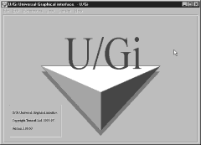

Configuring Your Terminal
The first time you start U/Gi, you will see the Choose a connection window.
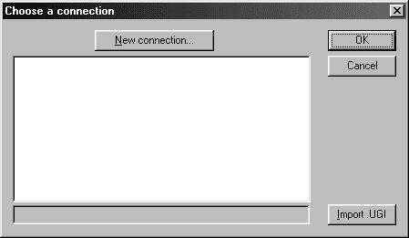

If you prefer, you can also disable the border around the terminal window in the View menu.
Click on the Import .UGI button. Select compu.ugi and click on OK.
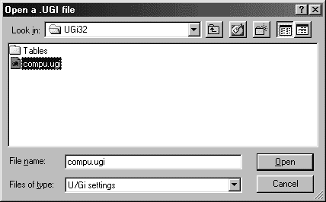
Click on OK again and you should get a login prompt. Next you will want to set your terminal settings. Select the Preferences menu and choose Terminal.
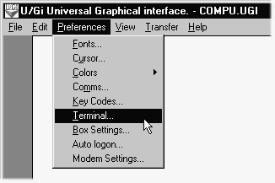
Please set the Rows to 25. Make sure your Terminal Type is set to “ANSI”. Click on OK.
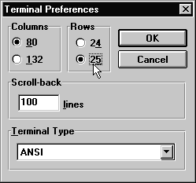

Saving Your Settings
You will want to save your settings for future use. Click on the File menu and choose Save Preferences. Then choose File, Exit to end your U/Gi session.
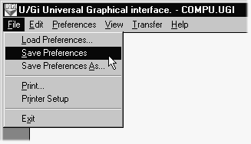

Appendix
A

Connecting with a Modem to a UNIX host
To connect by modem, you will need to know the number you must call to connect to your main UNIX host. You will also need to have your Comm… setting in the Preferences menu set for the serial port of your modem.

Calling your UNIX Host

It is assumed that you have already completed the serial connection setup.
You will be presented with the U/Gi interface. Make sure your modem is turned on, and plugged into your computer. Then, type in AT and hit ENTER. You should see the text OK appear on the next line.
Next, type ATDT and the phone number you must dial for the UNIX host. For example, type in ATDT17145222505. Any area codes and prefixes you must dial to call an outside line must also be included.

If you dial “9” to get an outside line, you may need to add a “9” to your number as well.
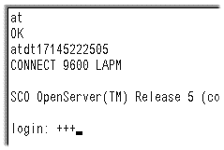Your modem will dial the number, and when it receives an answer, there will be some varying pitches of sound while the two modems negotiate. When this ends, you should see the words CONNECT 9600 LAPM on your screen. At this point, hit enter to continue, and you should be prompted with a login: prompt. Type in your login name and password here to access your UNIX host.
In order to disconnect from your UNIX host, first exit any programs you are running. You must be at a login: prompt before you disconnect. In order to disconnect, type +++ (three plus signs ) and then type in ATH0. (You will only see the +++ on your screen.) If you need further assistance, speak with your Network Administrator, or call a Compusource Systems Engineer.

Do NOT do this unless you are at a login: prompt!

Appendix
B

Connecting with a Modem to a Windows host
To connect by modem, you will need to have Remote Access Service running on the Windows NT Server. Also, your NT user account must have dial-in privileges.
To connect to your Compusource Application, dial in to the Windows NT Server using Dial-up Networking. After your connection has been established, double-click on U/Gi to start your Compusource session. See your system administrator for details.

Connecting via the Internet
C
To connect to your Compusource server via the Internet, your system must have a permanent, fixed Internet connection. You will need to know the IP address of your Internet router and, if necessary, the TCP service port for connecting to your Compusource server.

Installing U/Gi for using the Internet

Write down your
Compusource server’s Internet IP address here:
______________________

Write down your
TCP service port number:
______________________
When you followed the instructions for installing U/Gi, you should use the Internet IP address of your server instead of the local IP address of your server.
Setting up U/Gi to connect to your server via the Internet requires one extra step during the connection import process. The first time you start U/Gi, you will see the Choose a connection window. Click on the Import .UGI button. Select compu.ugi and click on OK.
The Host name field will contain the Internet IP address you provided during installation. The Port field will default to 23, please change the number to your unique TCP service port number. Click OK to continue.

If you prefer, you can also disable the border around the terminal window in the View menu.
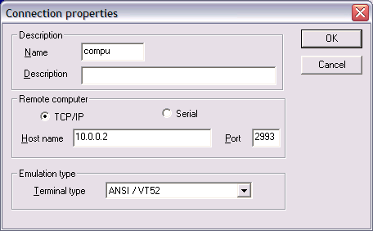

Make sure you
are already connected to the Internet before starting U/Gi via the Internet.
To get a login, first connect to the Internet., then run U/Gi.

