Windows NT Server

Microsoft Backups

To perform a backup of your system, have every user log out of the Compusource software and disconnect from the Windows NT Server. It is recommended that you perform your backups at the close of business day, as the backup can take several hours to run as well as verify.
As a rule, Windows NT Backup is not able to back up files which are in use. A file which is in use is called an open file. However, if you have software which allows you to back up open files, then you will not have to perform the instructions following paragraph. Otherwise, please insure that your data will be properly backed up.
To begin, log in as an Administrator on the NT Server. Have everyone log out of the Compusource software. Please make sure that all users are logged out. To check this, run the UBL Monitor. There should be an icon on the desktop, or you can go to START > Programs > UBL 2.0 > UBL Monitor. Make sure that no processes are running and then continue.
Figure 1: Accessing UBL Monitor
It is VERY important that you get all users out of your Compusource application before continuing. Open files WILL NOT be backed up!!
Next, start the Microsoft Backup utility. Access Backup by going through the following menus: START > Programs > Administrative Tools > Backup.
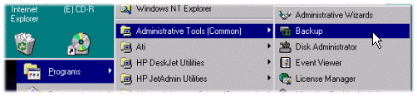
Figure 2: Accessing Backup
You will be presented with the following screen. Insert a tape into your tape drive. You will need to select the drives to backup. In the Drives window, click on the boxes next to your hard disk drives. These will usually be named “C:” and “D:” and should have an “X” in the box to designate them for backup. Figure 3 illustrates a typical screen for backup. Once you have selected your hard drives for backup, click on the button in the upper left corner labeled Backup.
Figure 3: Marking drives for backup
The following screen will appear, summarizing the backup procedure. By default, the option to Verify and the option to Backup the Local Registry will NOT be checked. Please click on these options so that your backup will be verified and the registry will be backed up.
Figure 4: Backup options
Once you have clicked on “OK” to proceed, you may be prompted to replace the data on the tape. Click on “YES” to proceed with the backup.
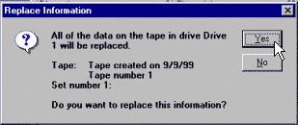
Figure 5: Replacing tape contents
The Backup Status window will be displayed. The backup could take several hours. Please wait while the backup completes.
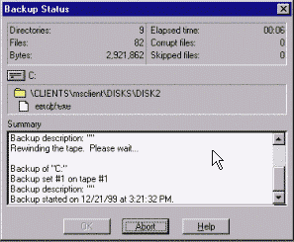
Figure 6: Backup status window
After the backup has completed, the verify cycle will begin. Again, please wait. Once the verify cycle has completed, the Backup Status window will display the following:
Verified N files in N directories.
N files were different.
Processed N bytes in N minutes.

Operation Completed.
Remove your backup tape and write today’s date on it. It is also recommended that, at the beginning of the month, you reboot your server.

