Windows 98 and ME Backups

Preparing for Backup

To perform a backup of your system, you must have every user log out of the Compusource software and disconnect from the Windows Server. It is recommended that you perform your backups at the close of business day, as the backup can take several hours to run as well as verify.
To begin, have everyone log out of the Compusource software. Please make sure that all users are logged out. To check this, run the UBL Monitor. You can go to START > Programs > UBL 2.0 > UBL Monitor. Make sure that no processes are running and then continue.
It is VERY important that you get all users out of your Compusource application before continuing. Open files WILL NOT be backed up!!
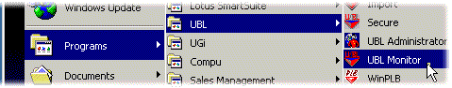
Figure 1: Accessing UBL Monitor
If you are unable to get all users out of the system, of if there are hung connections, you can reboot the server to disconnect all current logins before continuing with the backup.

Your first Backup

Next, start the Microsoft Backup utility. Access Backup by going through the following menus: START > Accessories > System Tools > Backup.
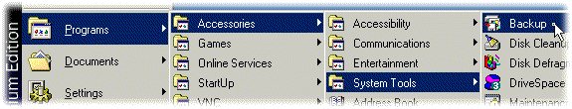
Figure 2: Accessing Backup
The very first time you run a backup, there will not be any backup jobs defined yet. Do define a backup job, follow the steps on the following page. If you have already done the steps on the following pages, skip to page 5, Opening Existing Backup Jobs.
The first time you run a backup, you will want to have Windows walk you through creating a backup job. You will be presented with the following screen. Insert a tape into your tape drive.
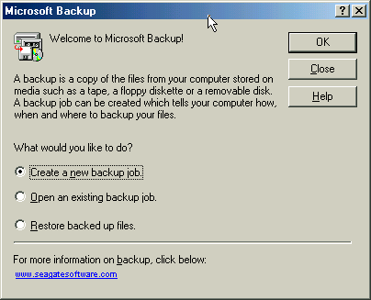
Figure 3: Windows Backup Welcome Screen
Click on Create a new backup job, then click on the OK button. You can click on the Next button to advance through the screens. The following screen will appear, asking you what you want to back up. By default, Windows will prompt you to back up everything on your computer. Accept this default and click on Next.
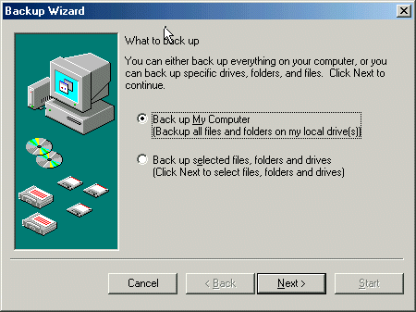
Figure 4: Backup Wizard – What to Back Up
TIP: | You will also be prompt to backup all files or changed files. It is highly recommended that you always choose All selected files. Click Next to continue. | 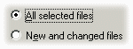
Next, you will be asked to specify where the backup will be stored. Usually, this would be a tape drive or other removable archive media. Select your tape drive or other backup device and click Next to continue.
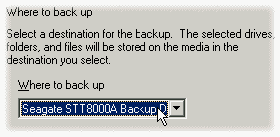
Figure 5: Where to Store the Backup
You can also back up to a file on your hard disk, then copy the file to a CD-ROM. If you are using a CD-R or CD-RW for backups, and you have installed software to allow your computer to treat the CD-R or CD-RW as a hard drive, then you can backup directly to the CD. To accomplish this, select backup media type File, and specify a file name on the drive letter associated with the CD. For example, if your CR-RW is drive E:, then the file name could be E:\Backup.qic.
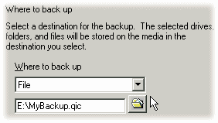
Figure 6: Backing up to file
An example of such software would be Adaptec DirectCD.
Next, you will be asked if you want to compare the backup / verify and compress the backup data. Always select the option to compare the backup. Compression is not necessary unless your data exceeds the tape capacity. Click on Next.
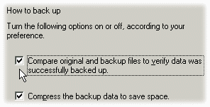
Figure 7: Advanced Backup Options
Lastly, you will be presented with a summary of the backup job. The default settings are to do a Normal backup, verify the files, to prompt you before replacing any contents on the tape and to run the backup right now.
Once you have clicked on Start to proceed, you may be prompted to replace the data on the tape. Click on YES to proceed with the backup. You may also be prompted to name the backup job. Enter something meaningful, like “04/01/01 Full Backup.”
The Backup Status window will be displayed. The backup could take several hours. Please wait while the backup completes.
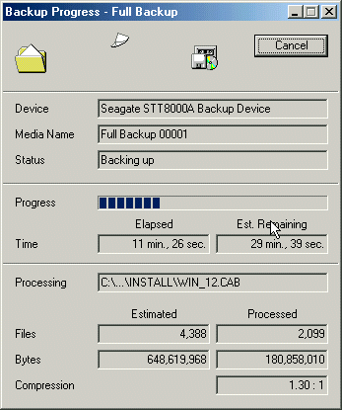
Figure 8: Backup progress window
After the backup has completed, the verify cycle will begin. Again, please wait. Once the verify cycle has completed, Windows will notifying you with a small button. Click on OK to continue.
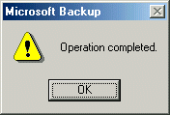
Figure 9: Backup progress window
Finally, the Backup Progress window will display. Look for the words “Backup complete – No errors” in the Status line.
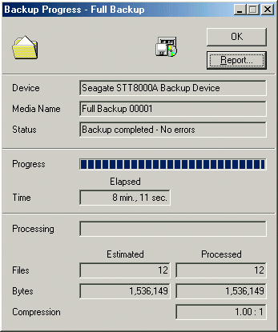
Figure 10: Backup completed with no errors
If the status line indicates that the backup completed with errors, or if the backup failed, please check the backup report by clicking on the Report button.
If your backup completed without errors, remove your backup tape and write today’s date on it. It is also recommended that, at the beginning of the month, you reboot your server.

Opening Existing Backup Jobs

Once you have completed the initial backup, there will be a backup job named “Full Backup.” In the future, you can start the same backup job by opening this backup job by doing the following:
To begin, have everyone log out of the Compusource software. Please make sure that all users are logged out. To check this, run the UBL Monitor. You can go to START > Programs > UBL 2.0 > UBL Monitor. Make sure that no processes are running and then continue.
It is VERY important that you get all users out of your Compusource application before continuing. Open files WILL NOT be backed up!!
Figure 11: Accessing UBL Monitor
Next, start the Microsoft Backup utility. Access Backup by going through the following menus: START > Accessories > System Tools > Backup.
Figure 12: Accessing Backup
You will see the following screen. Insert a tape into your tape drive.
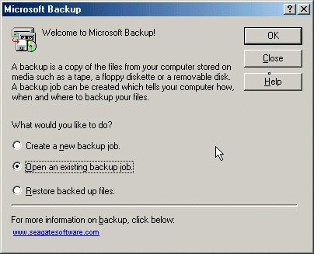
Figure 13: Windows Backup Welcome Screen
Click on Open an existing backup job, then click on the OK button.
Next, select the “Full Backup” job, and click on the Open button.
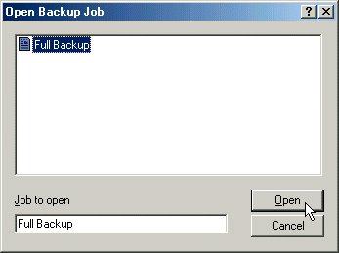
Figure 14: Windows Backup Welcome Screen
Instead of being presented with another wizard, you will see the main Microsoft Backup window… Click on the Start button to start your backup.
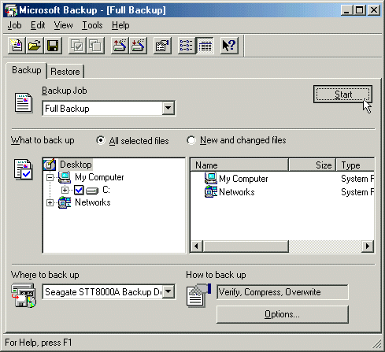
Figure 15: Starting the Backup Job

Backup Job Preferences
If you do not want to be prompted each time to overwrite the media, or to change compression settings, click on the Tools menu and choose Preferences. Here you can setup these options. Be sure to click on Job menu and choose Save when you are done.
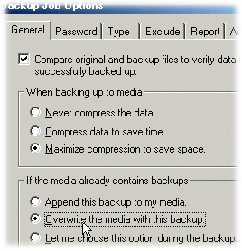
Figure 16: Backup Job Options

