Windows 2000 Backups

Scheduled Microsoft Backups

If you purchased your Windows 2000 Server from Compusource, out systems engineers will have setup a scheduled backup on your server. You can check the results of the automated backups by following the instructions in this document.
To begin, log in as an Administrator on the Windows 2000 Server. Next, start the Microsoft Backup utility. Access Backup by going through the following menus: START > Accessories > System Tools > Backup.
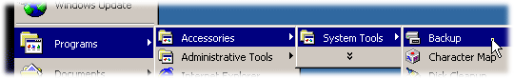
Figure 1: Accessing Backup
TIP: | If you do not see the Accessories group, click on the down arrow at the bottom of the main Programs group to display rarely used menus. | 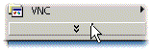
You will be presented with the following screen. Click on the Tools menu, and select the Reports option to read the report.
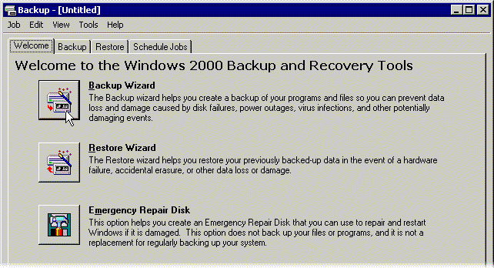
Figure 2: Windows 2000 Backup Welcome Screen
You will see a box appear, which will show up to 10 dates. Select the line dated from last night. This will be your most recent backup, and should be the top line.
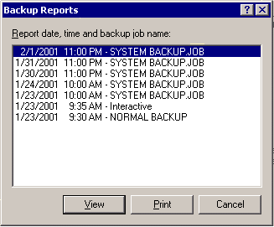
Figure 3: Windows 2000 Backup Reports window
Once you have selected the most recent backup report, click on the View button.
The backup report has two sections... Backup and Verify. In the top section, look for the lines that read
Backup of "C:" and
Backup of "System State"
We want to make sure that the started and completed OK. To do so, look for the lines that read:
Backup started on 2/1/2001 at 11:10 PM.
Backup completed on 2/1/2001 at 11:12 PM.
For every drive that is backed up, there will also be a corresponding Verify section. Repeat the process in the Verify section, looking for the lines that read:
Verify of "C:" and

Verify of "System State"
Then, find the lines that read:
Verify started on 2/1/2001 at 11:22 PM.
Verify completed on 2/1/2001 at 11:24 PM.
If you see both the words started and completed for C: and System State, then your backup was good.
On the next page you will find an example of a backup report, and the lines to look for which indicate a good backup.

Sample Backup Report
Backup Status
Operation: Backup
Active backup destination: 4mm DDS
Media name: "Media created 2/1/2001 at 11:00 PM"

Backup of "C: "
Backup set #1 on media #1
Backup description: "Set created 2/1/2001 at 11:00 PM"
Backup Type: Normal

Backup started on 2/1/2001 at 11:00 PM.
Backup completed on 2/1/2001 at 11:10 PM.
Directories: 459
Files: 12600
Bytes: 911,659,394
Time: 9 minutes and 32 seconds
Media name: "Media created 2/1/2001 at 11:00 PM"

Backup of "System State"
Backup set #2 on media #1
Backup description: "Set created 2/1/2001 at 11:00 PM"
Backup Type: Copy

Backup started on 2/1/2001 at 11:10 PM.
Backup completed on 2/1/2001 at 11:12 PM.
Directories: 121
Files: 1899
Bytes: 246,754,708
Time: 2 minutes and 18 seconds

----------------------

Verify Status
Operation: Verify After Backup
Active backup destination: 4mm DDS

Verify of "C:"
Backup set #1 on media #1
Backup description: "Set created 2/1/2001 at 11:00 PM"
Verify started on 2/1/2001 at 11:13 PM.
Verify completed on 2/1/2001 at 11:22 PM.
Directories: 459
Files: 12600
Different: 0
Bytes: 911,659,394
Time: 9 minutes and 5 seconds

Verify of "System State"
Backup set #2 on media #1
Backup description: "Set created 2/1/2001 at 11:00 PM"
Verify started on 2/1/2001 at 11:22 PM.
Verify completed on 2/1/2001 at 11:24 PM.
Directories: 121
Files: 1899
Different: 0
Bytes: 246,754,708
Time: 2 minutes and 21 seconds

