Windows 2000 Backups

Manual Microsoft Backups

To perform a backup of your system, you must have every user log out of the Compusource software and disconnect from the Windows 2000 Server. It is recommended that you perform your backups at the close of business day, as the backup can take several hours to run as well as verify.
To begin, log in as an Administrator on the Windows 2000 Server. As a rule, Windows 2000 Backup is not able to back up files which are in use. A file which is in use is called an open file. However, if you have software which allows you to back up open files, then you will not have to perform the instructions following paragraph. Otherwise, please insure that your data will be properly backed up.
To make sure no files are in use during backup, have everyone log out of the Compusource software. Please make sure that all users are logged out. To check this, run the UBL Monitor. There should be an icon on the desktop, or you can go to START > Programs > UBL 2.0 > UBL Monitor. Make sure that no processes are running and then continue.
It is VERY important that you get all users out of your Compusource application before continuing. Open files WILL NOT be backed up!!
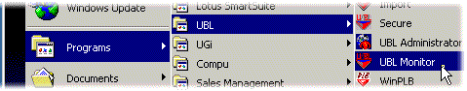
Figure 1: Accessing UBL Monitor
If you are unable to get all users out of the system, of if there are hung connections, you can reboot the server to disconnect all current logins before continuing with the backup.
Next, start the Microsoft Backup utility. Access Backup by going through the following menus: START > Accessories > System Tools > Backup.
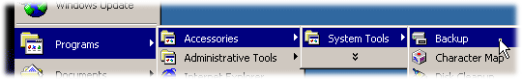
Figure 2: Accessing Backup
TIP: | If you do not see the Accessories group, click on the down arrow at the bottom of the main Programs group to display rarely used menus. | 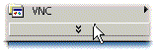
You will be presented with the following screen. Insert a tape into your tape drive. You will be using the Windows 2000 Backup Wizard to back up your computer.
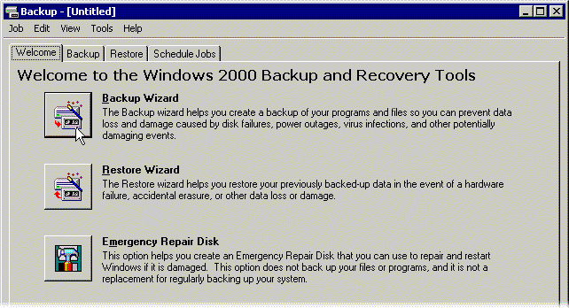
Figure 3: Windows 2000 Backup Welcome Screen
Click on the Backup Wizard button. You will see a welcome screen, click on the Next button to continue. The following screen will appear, asking you what you want to back up. By default, Windows 2000 will prompt you to back up everything on your computer. Accept this default and hit next to continue.
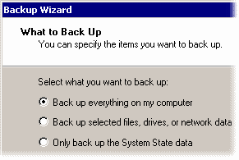
Figure 4: Backup Wizard – What to Back Up
Next, you will be asked to specify where the backup will be stored. Usually, this would be a tape drive or other removable archive media.
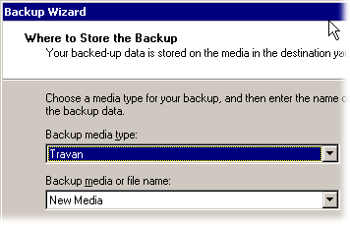
Figure 5: Where to Store the Backup
You can also back up to a file on your hard disk, then copy the file to a CD-ROM. If you are using a CD-R or CD-RW for backups, and you have installed software to allow your computer to treat the CD-R or CD-RW as a hard drive, then you can backup directly to the CD. To accomplish this, select backup media type File, and specify a file name on the drive letter associated with the CD. For example, if your CR-RW is drive E:, then the file name could be E:\Backup.bkf.
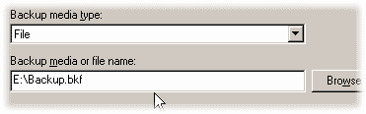
Figure 6: Backing up to file
An example of such software would be Adapatec DirectCD.
Lastly, you will be presented with a summary of the backup job. The default settings are to do a Normal backup, verify the files, to replace any contents on the tape and to run the backup right now. If you want to change the options, or to schedule the backup for a later time, click on the Advanced button to change these settings.
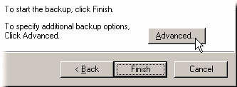
Figure 7: Advanced Backup Options
Once you have clicked on OK to proceed, you may be prompted to replace the data on the tape. Click on Yes to proceed with the backup.
The Backup Status window will be displayed. The backup could take several hours. Please wait while the backup completes.
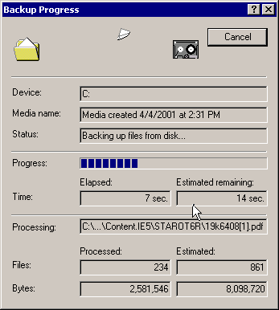
Figure 8: Backup progress window
After the backup has completed, the verify cycle will begin. Again, please wait. Once the verify cycle has completed, the Backup Progress window will display. Look for the word “Complete” in the Status line.
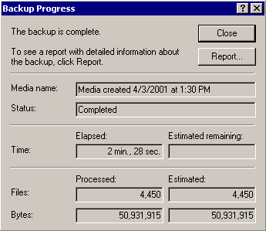
Figure 9: Backup progress window
If the status line indicates that the backup “Completed with Errors” or failed, please check the backup report by clicking on the Report button.
Remove your backup tape and write today’s date on it. It is also recommended that, at the beginning of the month, you reboot your server.

