Backup Procedure & ARCserve Storage

Manual Backup Procedure with ARCserve
- All workstations should be logged off the server before you begin a backup. No one should sign on to the system while a backup is being performed. Open files may not be backed up properly, and ARCserve may report errors.
- Login as an administrator on the main server.
- Insert a tape into the server’s tape drive. Make sure that the tape is not write-protected.
- Click on the Windows button. Select the Programs, then the ARCserver for Windows NT group, and click on Backup Wizard.
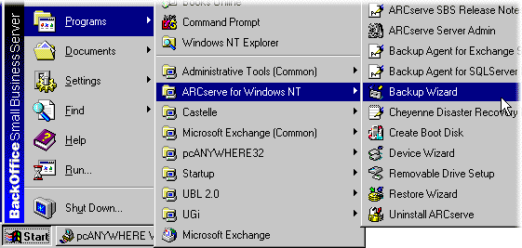
- You will see a tree display of your computer network. Click on the + signs to expand the network tree. The + sign on your main server display’s your server’s resources. Click on the green box next to the server icon to select the entire server. Click Next.
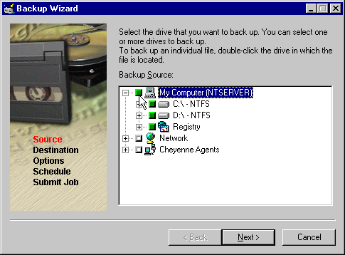
- You will be prompted for the device to back up your server with. Your tape drive will already be selected. Click on Next.
- Additional options will be shown to you. Leave the setting at Full Backup. Click on Next.
- You will be prompted to schedule the backup. The option “Run Now” will already be selected. You can click on the Schedule box to schedule a different time for this backup if you do not want to run it now. Then, click on Next.
- You will be prompted to describe this backup. Type in a name or take the suggestion, then click on Next.
- A progress indicator will be displayed. The server will begin to back up files. If more than one tape drive is necessary, you will be prompted to remove your first tape, and insert another one. Please wait for the backup to complete.
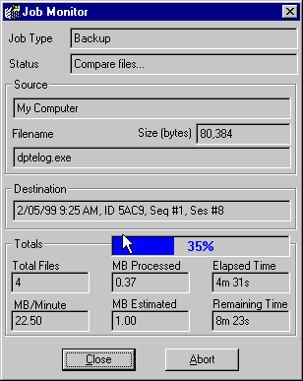
- If an error occurs please write down the message displayed on the screen. The backup should be restarted from the beginning. If you experience unexpected difficulties, or if you receive error messages, please call Compusource Hotline.
- Once you see the notification message appear, remove the tape and write the current date and time upon it.
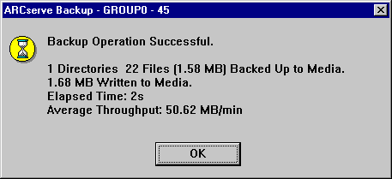

Verifying your ARCserve Backup
The ARCserve Storage Suite can be used to configure unattended backups which will run automatically at specified intervals. These scheduled backups are called “Backup Jobs.” ARCserve will also be configured to send out a message to a designated user regarding the backup each time one is attempted. This message contains information concerning the time of the backup, how much data was backed up, how much room is left on the backup tape, etc. After verification of a good backup, change to the next tape in your backup rotation. Use your email program of choice to retrieve these messages.
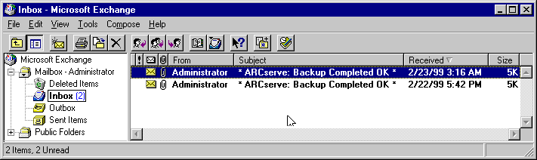
At the beginning of each day, the user responsible for backups should check for a message titled “ARCserve – Backup Completed” or something similar. If you see a messaged titled “ARCserve – Backup INCOMPLETE” then please examine the attached job log. The job log summarizes the backup job, and can be used to determine what was incomplete about the backup.
If you see a message titled “ARCserve – Backup FAILED!“ then please examine the attached job log for possible errors. Often, a failed backup results from not having a backup tape in the drive. However, if the error is not apparent, please call Compusource Hotline immediately.

Recovery Procedure
Disk or file recovery should only be done under the advisement of a Compusource Systems Engineer. If your hard disk drive has been completely destroyed, the disk may have to be initialized and reformatted before this recovery procedure can be done.
With your initial system setup and installation you should have received a set of installation diskettes and CD-ROMs. Please keep these installation media in a safe place. This media, alone with your last system backup tape, will be essential in the event that your system needs to be rebuilt.
Call Compusource Hotline and have a Compusource Systems Engineer talk you through the Recovery Procedure, or have Hotline do the Recovery over the modem if possible.

Summary of Procedure
This section is provided for your reference only. It is not meant as an instructional guide.
- The backup media and recovery media is located and secured by write protection.
- The system will be restored to a stable operating state. If total failure has been experienced, a reinstallation may be necessary.
- The tape backup device is set up, and all tape backup software is restored or installed.
- Tape contents are restored to the server.
- Contents are manipulated to fit current operating state of the server.
- Server is rebooted with restored data in place.
- Compusource Software functionality is tested.
- An assessment of lost work or data is done. Recovery or containment is attempted.

