OBJECTIVE

The purpose of this document is to detail a procedure that can be used to pay a vendor’s invoices with a credit card. This is becoming more common since some credit cards are now giving frequent flyer miles for credit card purchases.

ASSUMPTIONS

A Vendor record for the vendor already exists.

The invoices from the vendor have already been entered into the system as an open payable.

No check will be printed. This will be processed as a manual check and paid with a credit card.

You will contact the vendor and provide the credit card info and indicate what specific invoices are being paid.

You must determine what specific invoices are being paid.

SETUP

Create a General Ledger - Liability Account for each credit card.

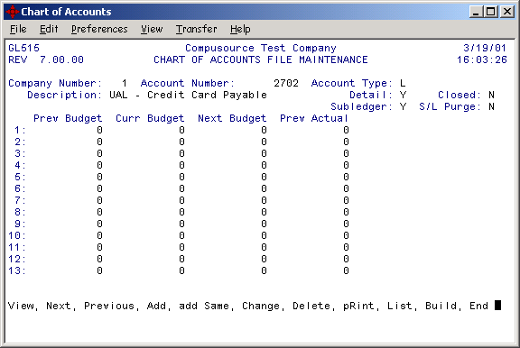

Create an Accounts Payable - Cash Code for each credit card.

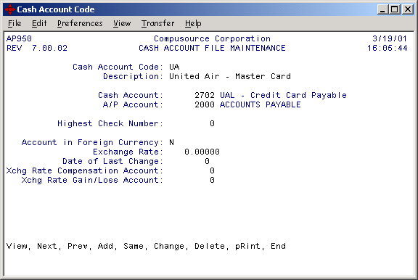

OPERATIONS

Accounts Payable – Manual Check Entry

Enter the manual check using the new cash account code for the credit card.

The check number is not critical, but it must not have been used before. I would just keep a log and always just use the next number.

Enter the specific invoices that are being paid for this vendor with the credit card.

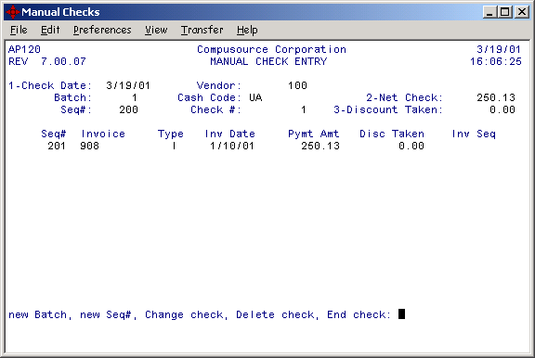

Data Entry Proof and Update

Proof and update this just as you would any other manual check.

You will get a Check Register Report.

This payment will exist in the check reconciliation file and can be reconciled to the statement from the credit card company.

GENERAL LEDGER POSTINGS
 | Cash |  |  | Accounts Payable |  |  | UAL - Master Card Payable |  |  | Expense Account
Enter Invoice from Vendor |  |  |  |  | 250.13 |  |  |  |  | 250.13
Pay Vendor w/ Credit Card |  |  |  | 250.13 |  |  |  | 250.13
Enter Invoice from Credit Card |  |  |  |  | 250.13 |  | 250.13
Pay Credit Card Vendor |  | 250.13 |  | 250.13

PROPRIETARY NOTICE: This document contains information of a proprietary nature which is the property and trade secret of Compusource Corporation. Under no circumstances is the information contained in this document to be used, copied, or reproduced without the prior written consent of Compusource Corporation.

