- Overview
  - The CONTRAC2 Job Cost module is used by about 25% of our accounts and they are mostly HVAC contractors.
  - Many accounts question whether they should use the Service Dispatch or the Job Cost package. You must use Job Cost if:
    - You want to enter estimated costs and compare them against the actual costs.
    - You require retention invoicing.
    - You need to do Percent of Completion or AIA invoicing.
    - You need Certified Payroll Reports.
    - You need to manage large jobs.
    - You need to manage jobs that will run for a long period of time.
    - You need to be able to see job cost reports after the job has been billed multiple times.
- Accounting Considerations - Work In Process Or Direct Expense
  - Work in Process Method
    - All costs are accrued in an asset account and on the balance statement. They can be transferred to the COGS expense accounts at a later time.
    - Most large companies that do large jobs use the work in process accounting method. The work in process method requires more work and someone to do the closeouts and balance the work in process accrual account.
    - A company must select either the Percent Complete or Completed Contracts method per the IRS.
    - Percent Complete is used by almost all of our accounts that use the work in process accounting method.
    - The Percent Complete method allows a job to be invoiced multiple times.
    - The Percent Complete method allows the WIP Closeouts to be done multiple times.
  - Direct Expense Method
    - Smaller companies use this method.
    - All costs go directly to the COGS expense accounts and the income statement.
- Setup Requirements
  - Type File (JTYPE)
  - Predefined Cost Codes (JCPRE)
  - G/L Job Closing Table (GLTBL)
  - Job Master (JMAST)
    - R Contract/Change Order File (CDETL)
      - Enter the total amount of the contract or change order.
    - B Contract Breakdown File (CBRAK)
      - Enter the contract-billing breakdown detail that will determine how the invoices generated through the Enter/Print Contract Bills program will look.
    - T Job Cost Summary File (JCOST)
      - Enter the estimated costs for the contract or change order.
- Job Cost Menus
  - Job Cost Menu
    - 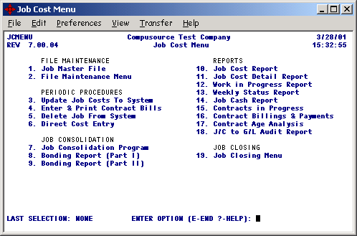
  - Job Cost File Maintenance Menu
    - 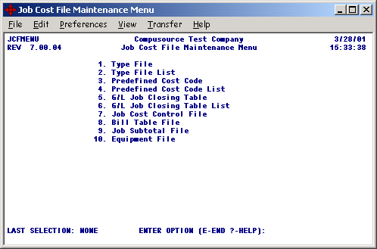

- System Data Flow
  - The Job Cost System is very similar to the General Ledger System in many ways.
  - Just as all of the accounting modules interface with GL, all of the accounting modules interface with JC.
  - In GL you need a company and account number, in JC you need a job number and cost code.
  - In GL you have a JOURNAL file, in JC you have a JTRAN file.
  - In GL you have a GLDETL file that the financials use, in JC you have a JBDET file that the job cost reports use.
  - In GL you need to post your journals in order to see the results on your trial balance and financial statements, in JC you need to run Update Job Costs to System before the costs will print on your JC reports.
  - Once the Job has been setup, all of the accounting modules can apply costs against the job by entering the job number and cost code.
  - Job Cost Integration Flow Chart:
Trial Balance
Financials
Job Cost Reports
Job Cost Detail Report
The Job Cost Reports are as current as the last time the Update Job Cost to System program was run.
Accounts Payable
Accounts Receivable
Payroll
Job Cost Contract Billing
Inventory Control
Entry
Edit
Update
JOURNAL
GLDETL
JBDET
JTRAN
Any transaction that has a job # and a cost code entered will cause a JTRAN record to be created.
You can enter a job # and cost code to JOURNAL records.
The Update Job Cost to System program will move the JTRAN records to the JBDET file.

  - Job Cost Report
Job Cost Reports
JCOST
JBDET
JMAST
    - The important thing to note here is that if no JCOST record is found, the JBDET records that reference that JCOST record will NOT be selected. This report prints summary totals with cost code being the greatest level of detail.

  - Job Cost Detail Report
Job Cost Detail Report
JBDET

    - This report runs directly off the JBDET file and is used to audit the summary costs that print on the Job Cost Report.
- Terminology
  - Job Number
    - This refers to the Job Master file record (JMAST) that is assigned a number manually when the job is setup. Some accounts refer to service orders as jobs also.
  - Type
    - Type Codes are major categories user to track costs. They can have up to 20 type codes. These usually include labor, material, subcontractors, permits and equipment rental.
    - Job Cost Reports subtotal by these type codes.
    - The type code determines the GL postings for all costs referencing a job number and cost code.
  - Cost Codes
    - Cost codes are the detail breakdown of the type codes. Every cost code references a type code. Most of our accounts are setup so that they can have up to 1000 cost codes per type.
    - An example of this would be if type 1 was for labor:
      - 1001 Startup Labor
      - 1002 A/C Labor
      - 1003 Ducting Labor
      - 1999 Labor Close Out
    - The Job Cost Report by Cost Code will subtotal by cost codes and type codes.
    - Cost Codes need to be setup in the Predefined Cost Code file.
  - Work In Process (WIP)
    - This is sometimes referred to as Work in Progress also.
    - This refers to costs that have been accrued into an asset account that have not yet been transferred to the cost of goods sold account (COGS).
  - Change Order
    - A change order used to track the original contracts contract amount and all costs associated with it. The original contract amount should be entered with a change order number of 1. And additional changes to the contract will be assigned a change order of 2 or greater.
    - Example
      - Change order 1 - Original contract to replace A/C Unit $6,000
      - Change order 2 – Repair Heater $1,000
  - Estimated Costs
    - These are the costs that have been budgeted for a job. They are entered through the Job Master File that are used in the job cost reports to compare against the actual costs so that you can manage your costs so that you hopefully do not go over budget.
    - When estimated costs are entered, the costs will reference a change order.
  - Committed Cost
    - These are costs that refer to a column on the Job Cost Report.
    - Committed costs usually refer to costs that are entered on purchase orders.
    - There is a Committed Update Flag in the Type file that can cause estimated or actual costs to also show as committed costs.
  - Actual Costs
    - These are your actual costs for a job that have been paid to employees and vendors.
  - WIP Costs
    - These are the costs that have been accrued in your work in progress asset account that have not been transferred to the cost of goods sold account.
    - WIP = Total Costs – Closed Costs
  - Retention
    - This is a percentage of the contract amount that the customer cannot be billed for until a specified time after the work has been completed. This is a requirement of the customers so that the contractor will fix and subsequent problems that may arise. They can offset the retention with any costs that the contractor does not handle.
    - This is usually a condition of the original contract.
    - An example of this would be $5,000 contract with 10% retention for 90 days.
      - When the job is billed at 100% the system will print an invoice for $4,500 and indicate that $500 retention is being withheld. The balance of $500 can be invoiced 90 days later.
- Hotline Calls – What Information Should I Get?
  - Get the job number & cost code or range or job numbers & cost codes when ever possible.
  - Many accounts do not understand the runtime prompts for the job cost reports. Try to determine how the runtime prompts were entered for the job cost report. The runtime prompts are saved in the new release.
  - For questions regarding a job cost report, try to get them to fax us a copy of the job cost report and have them circle the total in question.
  - Job Cost Reports are date sensitive by fiscal period range. Try to determine the range of fiscal periods the report was run for.
  - Try to determine what program or process they were running and of course any error message.
- Common Support Questions
  - Why do I not see my costs on the job cost report?
    - Have you run the Update Job Costs to System program yet?
    - The job cost reports read the JMAST record to get the JCOST records to get the JBDET records. The JC reports print summary totals by JCOST record.
      - If a JCOST record is missing, the report will not print the totals for the cost code even if JBDET records exist. This is not a frequent problem.
  - Why is the total billed amount is wrong on the job cost report?
    - Did someone change the total in the job master file?
    - Has all the billing been done using the Enter & Print Contract Bills program?
    - Service billings do not interface with JC.
    - The AR invoicing system and AR Data Entry interfaces with JC if they remember to enter the job number.
    - You can view the ARTRN record and see if there is a job number was entered.
  - Why is the employee name is not printing on the Job Cost Detail Report?
    - The employee number is not numeric.
    - The report reads the JBDET file and uses the reference field to determine the employee name. The employee number must be numeric for this report to print the employee name.
  - Can I use the direct cost entry program to add costs to a job that were not coded to a job when the AP invoice was entered?
    - The Direct Cost Entry program allows JTRAN records to be added. This is only for entering beginning balances when a new account starts using the system. This does not interface with GL at all. This will cause auditing problems. This will always cause the WIP to be out of balance with the GL.
  - How are the invoice numbers determined by the contract billing Invoices?
    - The program uses the Inv # field from the Job Master file record (JMAST). The program will add one to that number and if that invoice number does not exist in the INVH file, it will be used, otherwise it will continue to be incremented and check INVH until an INVH record with that number is not found.
  - Why do the COGS postings on the trial balance report appear to be incorrect?
    - Are they using the Direct Expense or WIP method?
      - You can determine this by checking the JC Type file (JTYPE) and look at the G/L Low Number value. If this is an asset account, they are using the WIP method. If it is an expense account, they are using the direct expense method.
    - WIP Method:
      - The GL Job Closing Table entry in the job master record will determine how the costs are transferred to the COGS accounts for each type.
      - The WIP method used the GL account range in the JTYPE file to determine the WIP asset account to debit.
      - The WIP Closeout process moves the costs from the WIP accrual account to the COGS expense account. The accounts are determined by the G/L Job Closing Table (GLTBL) number in the JMAST record to determine the WIP account to be credited and the COGS account to be debited for each JTYPE record.
      - 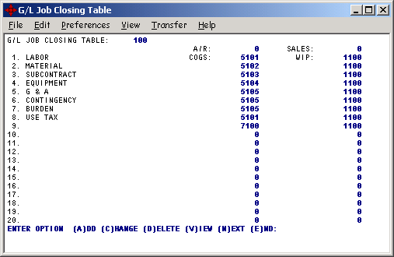
    - Direct Expense Method:
      - The GL account range in the JTYPE file to determine the COGS posting.
      - 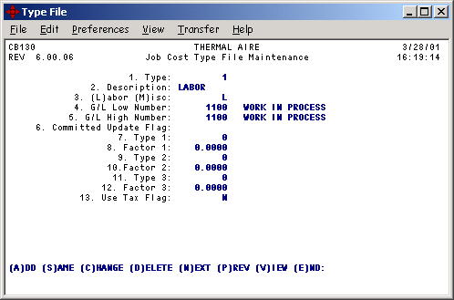
  - Do I need to run the WIP Job Closeout Process?
    - They only need to do that if they are using the WIP costing method.
  - How often do I need to do the WIP Job Closeout Process?
    - They have to make this decision. They should probably review this with their accountant.
    - This is usually done monthly when the billing is done. They usually want to claim the costs and sales in the same accounting period.
  - Why are the labor COGS postings are not going to the correct expense account? They are using the direct expense costing method.
    - Timecard entry always posts to the GL account determined by the JTYPE record in the G/L Low Number field. Some new accounts do not understand that the G/L Low Number and G/L High Number values in the JTYPE file only work in AP. In AP they can change the account to any account number in the range of G/L Low Number and G/L High Number.
  - Why is the operator not prompted for a job number and cost code when entering an AP invoice?
    - In the GL Control file, the J/C Interface flag is not set to "Y".
  - Why are my committed costs from purchase orders missing from the Job Cost Report?
    - Was the job number and cost code was entered on the purchase order line item?
    - They must not have entered an estimate for this job and cost code. A JCOST record for this must exist for it to print on the Job Cost Report. This is a common problem.
  - How do I flag a job to print AIA invoices?
    - All the system needs to know is that the "AIA No: " field in the job master record has a number entered in it.
    - The field help says, "To cause an AIA Invoice to print for this job, enter the AIA Application Number in this field. This will print on the AIA invoice and will be incremented by 1 by the system for each invoice".
  - Is there any month end processing required by the system?
    - No month end processing is required by the job cost system, but we do recommend:
      - Balancing the WIP accrual account by running the J/C to G/L Audit Report only if they are using the WIP accounting method.
  - How do I close a job?
    - You need to determine if they want to:
      - Flag the job so no more costs can be applied.
        - In the job master record (JMAST), set the Closed flag to "C".
      - Closeout the WIP costs to the COGS accounts. This process is also referred to as job closing.
        - Follow the steps detailed on the Job Closing Menu (JCCMENU). These steps must be done in the specific order that they are listed on the menu.
        - If this is not setup on their JC Menu you can:
          - Run AMCVMF on JCCMENU.MF and then add it to their JCMENU.
          - The menu file is located at /u/C2/C2PKG/JCCMENU.MF if you need to modem it over.
          - 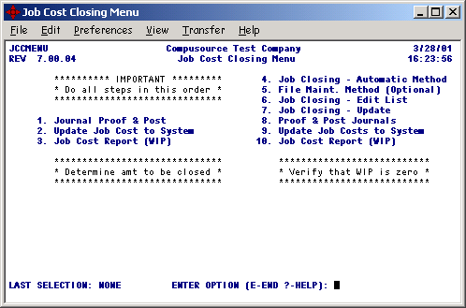
        - If they still have questions, refer them to a CONTRAC2 person.
  - Why are there are negative WIP totals after doing a WIP closeout?
    - 99% of the time this is because they did not do the steps detailed on the Job Closing Menu from beginning to end. They can just rerun the WIP closeout process again and it will make the necessary corrections.
  - What is the difference between WIP and Actual costs?
    - WIP (work in process) costs are the costs that have not been closed-out (transferred) from the WIP asset account to the COGS expense account.
      - For example if you have a job-to-date total of $10,000 costs and have previously closed-out $6,000 of WIP costs you would now have a total of $4,000 of WIP costs. WIP costs are usually important to the accounting department. Project managers generally look at the actual costs.
      - F.Y.I. the JBDET records for closeouts always have a cost code that ends with 999.
    - Actual Costs are total costs to date. Actual costs don't care about WIP closeouts.
    - In the example #1 below of $10,000, your actual costs would be $10,000.
  - WIP Closeout Chart
Step | Program | Reason | Example #1 | Example #2
1 | Journal Proof & Post | This needs to be done because we want ALL costs to be updated to the JTRAN file before closing-out the WIP. | No journals exist.  .00 | Job:100  CC: 1000 2,000  +2,000
2 | Update Job Cost to System | This will update all JTRAN records so that want ALL costs to be updated to the JBDET file so that the correct WIP is known for the closeout process. | No JTRAN records exist.  .00 | Job:100  CC: 1000 2,000  +2,000
3 | Job Cost Report | This should be run for WIP costs through the fiscal period being closed. This will show you the total costs that will be closed-out. | Job:100  CC: 1000 10,000  CC: 1999 6,000-  WIP: 4,000 | Job:100  CC: 1000 10,000  CC: 1000 2,000 New  CC: 1999 6,000-  WIP: 6,000
4 | Job Closing – Automatic Method | This will automatically calculate the amount of WIP that needs to be closed-out. This will match the totals on the previous Job Cost Report. | Job:100  CC: 1999 4,000- | Job:100  CC: 1999 6,000-
5 | Job Closing – Edit List | List the total WIP to be closed-out. | Job:100  CC: 1999 4,000- | Job:100  CC: 1999 6,000-
6 | File Maint. Method (Optional) | This is rarely used. This is only used if they want to closeout different amounts that the Job Cost Report calculated. | Not used.
7 | Job Closing - Update | This will take the WIP totals and create JOURNAL records that will CR WIP and DB the COGS accounts. | Job:100  CC: 1999 4,000-  CR 1100 4,000  DB 5101 4,000 | Job:100  CC: 1999 6,000-  CR 1100 6,000  DB 5101 6,000
8 | Journal Proof & Post | Proof & Post the JOURNAL records created by the Job Closing – Update and create the JTRAN records for the costs that were closed-out. | Job:100  CC: 1999 4,000-  CR 1100 4,000  DB 5101 4,000 | Job:100  CC: 1999 6,000-  CR 1100 6,000  DB 5101 6,000
9 | Update Job Cost to System | This will update all JTRAN records that were created when the closeout journals were posted. The result will be that the WIP on the Job Cost Report is zeroed out. | Job:100  CC: 1999 4,000- | Job:100  CC: 1999 6,000-
10 | Job Cost Report | This is printed to verify that the WIP is now zero. | WIP: .00 | WIP: .00

- Job Cost Reports
  - Job Cost Report
    - There are many job cost reports. This is the primary report that is used to manage their jobs.
    - Runtime Options
JC300 Compusource Test Company 4/02/01
REV 7.00.03 JOB COST REPORT 21:00:32

Level of Detail: 3 Cost Code
Job Status: 3 All
Report Type: 2 Actual
Sort by Type or Phase: T
Include Retention: Y
Percent of Cost or Sell: C
Billed PO's to reduce Committed Cost: N

Start End
Soft Close Date: 0 0
Range of Jobs: 777.0000 777.0000
G/L Periods: First Last
Types: First Last

Terminal or Printer: P
Print options on 1st page: Y

Is the above information OK [Y]/N/E: Y

Enter 1-Job, 2-Type, or 3-Cost Code detail

    - Job Cost Report Example
JOB: 777.0000 LUCKY SEVEN B ORIG AMT: 6,000.00 BILLED: 0.00 RUN DATE: 4/02/01
CUST: 200 TOM O MALLEY CHANGES : 0.00 RETN: 0.00 START: 3/01/01
SLS : 1 TOTAL : 6,000.00 PAID: 0.00 G/L PER: ALL

**** QUANTITY **** ****************** DOLLARS *******************
COST CODE DESCRIPTION UNIT EST ACTUAL EST COMMIT ACTUAL DIFF
1001 PREFABRICATION LABOR HR 30.00 1,000.00 0.00 0.00 1,000.00
1002 ROUGH,IN LABOR HR 40.00 1,000.00 0.00 0.00 1,000.00
** TOTAL LABOR ** 70.00 2,000.00 0.00 0.00 2,000.00

2001 PREFABRICATION MATERIAL EA 2,000.00 1,797.50 0.00 2,000.00
2003 FINISH MATERIAL EA 500.00 0.00 0.00 500.00
** TOTAL MATERIAL ** 2,500.00 1,797.50 0.00 2,500.00

3001 PREFABRICATION SUBCONTRACT EA 1.00 500.00 400.00 0.00 500.00
** TOTAL SUBCONTRACT ** 500.00 400.00 0.00 500.00

** TOTAL EQUIPMENT ** 0.00 0.00 0.00 0.00

** TOTAL G & A ** 0.00 0.00 0.00 0.00

** TOTAL CONTINGENCY ** 0.00 0.00 0.00 0.00

** TOTAL BURDEN ** 0.00 0.00 0.00 0.00

** TOTAL USE TAX ** 0.00 0.00 0.00 0.00

*** TOTAL JOB LUCKY SEVEN BUSINESS 70.00 5,000.00 2,197.50 0.00 5,000.00

ESTIMATED COMMITTED ACTUAL COMP BILLED PROFIT ACT/BILL
TOTAL COST 5,000.00 2,197.50 0.00 0.00 % 0.00 % 100.00 % 0.00 %
GROSS PROF 1,000.00 3,802.50 6,000.00
PROFIT % 20.00 % 173.03 % 0.00 %

  - Job Cost Detail Report
    - This is the report that is used to look at the detail behind the summary totals that were reported on the Job Cost Report This is how you audit the job cost report.
    - Runtime Options
JC333 Compusource Test Company
REV 7.00.03 Job Cost Detail Report

Start End
Range of Jobs: 777.0000 777.0000
G/L Periods: 01/01 02/02
Cost Codes: First Last

Print 1 page per Job: N

Print options on 1st page: N

Is the above information OK [Y]/N/E: Y

Enter Starting Job # or 'BLANK' to start with first

    - Job Cost Detail Report Example
04/02/01 JOB COST DETAIL REPORT JC333
16:17:03 PAGE 0001

JOB COST GL POSTING SRC DESCRIPTION REFERENCE ACTUAL UNIT ACTUAL ACTUAL
NUMBER CODE PER DATE NUMBER UNITS MEAS HOURS DOLLARS

777.0000 1001 401 40201 PR 4 1 01 PYCD 2 101 0.00 HOUR 2.00 60.05 NEAL, WILLIAM J
40201 PR 4 1 01 PYCD 1 101 0.00 HOUR 8.00 186.80 NEAL, WILLIAM J

0.00 10.00 246.85 *

777.0000 1002 401 40201 PR 4 2 01 PYCD 1 101 0.00 HOUR 2.00 46.70 NEAL, WILLIAM J

0.00 2.00 46.70 *

777.0000 2001 401 40201 AP 1262 1262 100 0.00 0.00 12.00 Carrier
40201 AP 1262 1262 100 0.00 0.00 1,737.50 Carrier

0.00 0.00 1,749.50 *

777.0000 3001 401 40201 AP 1263 1263 200 0.00 0.00 400.00 SILICON EXPRESS

0.00 0.00 400.00 *

0.00 12.00 2,443.05 **

0.00 12.00 2,443.05 ***

