OVERVIEW

The Compusource - Ascente Service Dispatching System is a service management system that is designed primarily for the plumbing and HVAC industries. This Ascente system integrates with the Open System – Traverse Accounting System.

The Ascente – Service Dispatching System performs the accounting function of invoicing. The following general ledger postings will result:
- Cash
- Accounts Receivable
- Inventory
- Sales Tax Payable
- Sales
- Cost of Goods Sold

This document is intended to:
- Explain in detail the setup requirements for the Traverse, General Ledger module necessary for Ascente.
- Explain the setup requirements for Ascente that will determine the GL postings that will be passed to the Traverse System.
- Explain how Ascente determines the GL accounts which sales and costs will post.
- Explain how Ascente determines the GL accounts that cash, accounts receivable, inventory, and sales tax will post.
- Provide an overview of the Ascente invoice processing cycle.

Traverse Company Selection

Traverse allows multiple-company setup. Each company in Traverse is assigned a three-character code. Ascente must know to which Traverse company entries should be posted.

Traverse Chart of Accounts Requirements

Traverse uses a segmented chart of accounts.

We strongly recommend that that there be at least three segments to every account number.

Every segment of the account number has its own designation.

Account number 4100-01-02 (Service Sales – California – Heating) is a compilation of three segments: main, branch and department.
      - Main
        - This is the general account number. For example:
          - 4100 for Service Sales.
          - 4200 for Construction Sales
      - Branch
        - You can have multiple branches. For example:
          - 01 for California
          - 02 for Nevada
      - Department
        - You can have multiple departments. For example:
          - 01 for Plumbing
          - 02 for Heating
          - 03 for Air Conditioning
          - 04 for Electrical
  - These segments are important to remember because Ascente has logic that will calculate the sales and costs-of-goods-sold accounts for every item.

- Traverse Company Selection
  - The Traverse Company with which Ascente will interface is determined in the Ascente / Maintenance / Options and Interfaces program in the General tab.
    - Traverse Company ID
      - Select the Traverse Company with which Ascente will interface.
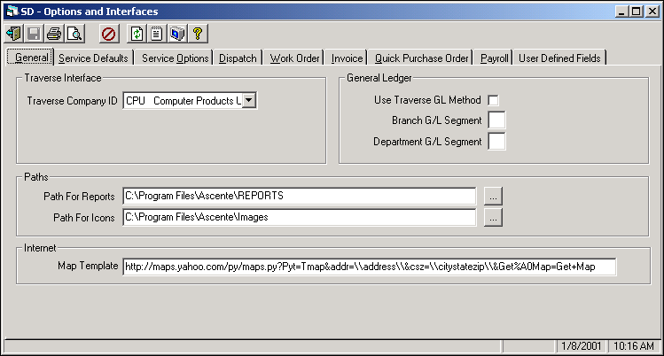

Figure 1 - Service Dispatch Setup Manual 15-2

NOTE: The Traverse database must be linked to the correct Traverse Company database in addition to having this Traverse Company ID set. The MDBADMIN utility must be run to unlink from the first company and then link to the new band.

This is usually located in the C:\Program Files\Ascente Service Dispatching Application directory.

- Ascente Branch & Department Segment Assignment
  - Segments are assigned in the Ascente / Maintenance / Options and Interfaces program in the Invoice tab.
    - Use Traverse GL Method
      - We recommend that this option be not selected, if sales and cost of sales will be distributed to more that one cost center.
    - Branch G/L Segment
      - Enter the segment used to determine the branch. If the department is not related to a G/L segment, leave this blank.
    - Ascente - General Ledger Interface to Traverse Setup Requirements Department G/L Segment
      - Enter the segment used to determine department.
Figure 2 - Service Dispatch Setup Manual 15-2

NOTE: We recommend, but do not require, that the chart of account numbers be segmented in the order of main, branch and department.

4100-01-02: Service Sales – California – Heating

By using the settings above, segment #2 is designated the branch id
You can use a different order to the segments. The Ascente / Maintenance / Options and Interfaces program in the Invoice tab is where the branch and department segments are designated in Ascente.

Figure 8 - Service Dispatch Setup Manual 32 – 8
- Branch GL Segment
  - The Branch Segment Numbers are assigned to each Branch record using the Ascente/ Maintenance/ Branch program.
    - Ascente has the option of allowing the branch to overlay the general ledger number. The Ascente / Maintenance / Options and Interfaces / Invoice tab / General Ledger panel contains the branch G/L segment to use. If a segment number is entered in the Ascente / Maintenance / Options and Interfaces program in the Invoice tab in the Branch G/L Segment field, the valid choices for that segment will be presented here.
    - These Branch records must be added into Ascente.
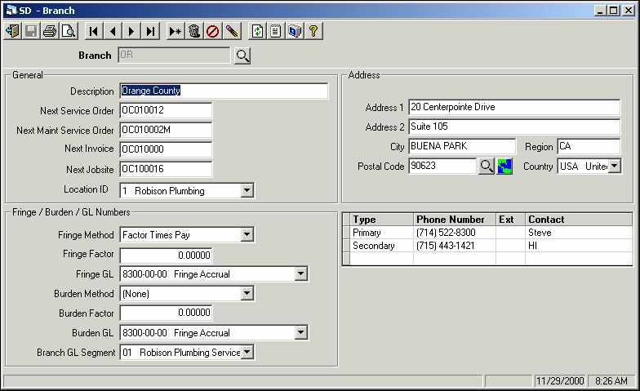
Figure 3 - Service Dispatch Setup Manual 15-6 Ascente / Maintenance / Options and Interfaces / Invoice tab

- Department Segments
  - The Department Segment Numbers are defined by using the Maintenance / Department program.
    - The Department file defines profit centers to be used for Departmental Profit and Loss reports. One Department record must be set up for each General Ledger cost center that is used for any branch. The Department file can overlay the Department segment for default General Ledger numbers (revenue and costs).
      - Department GL Segment
        - Ascente has the option of allowing the department to overlay the General Ledger number. The Maintenance/ Options and Interfaces/ Invoice tab/ General Ledger panel contains the Department G/L Segment to use. If a segment number is entered, the valid choices for that segment will be presented here. This links the segment number from Traverse to the Ascente Department code. This segment number will be used to overlay the department segment of a base account number.
      - Based Fixed Price GL No.
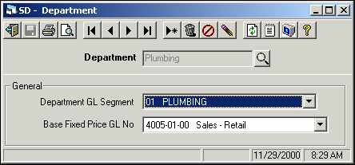
        - For this department, enter the General Ledger number for sales (revenue) associated with this fixed price (or not to exceed work that exceeds the price). Work Order Entry will use this number as a base. The Branch and/or Department records may overlay segments on top of this number.

Figure 4 - Service Dispatch Setup Manual 15-9

- Bill Types
  - The Bill Types are defined by using the Maintenance / Bill Type program.
    - Bill Types define logical groupings for General Ledger postings and commission calculations. At a minimum, there will be two bill types, one for labor and one for material. There is no limit to the number of bill types that can be set up. Every item entered on a work order will reference a Bill Type. The Bill Type determines the base GL account for the sales and cost of goods sold postings for a work order item.
      - Base Sales G/L #
        - Enter the General Ledger number for sales (revenue) associated with this bill type. The Work Order Entry and the Create Maintenance Service Orders programs will use this number as a base account. The branch and/or department records may overlay segments on top of this number.
      - Base Cost G/L #
        - Enter the General Ledger number for cost of goods sold associated with this bill type. The Work Order Entry and the Create Maintenance Service Orders programs will use this number as a base account. The branch and/or department records may overlay segments on top of this number.

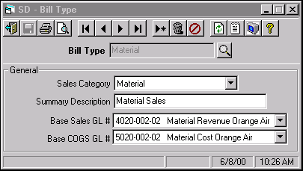
Figure 5 - Service Dispatch Setup Manual 15-3

- Ascente Service Order Coding for General Ledger Postings
  - Call Taking
    - Every service order has a Branch Code on the General Tab that will have a default value that can be changed.
      - The Branch Code on the General Tab will determine the Branch G/L Segment.
    - Every service order has a Department Code that will have a default value that can be changed.
      - The Department Code will determine the Department G/L Segment.

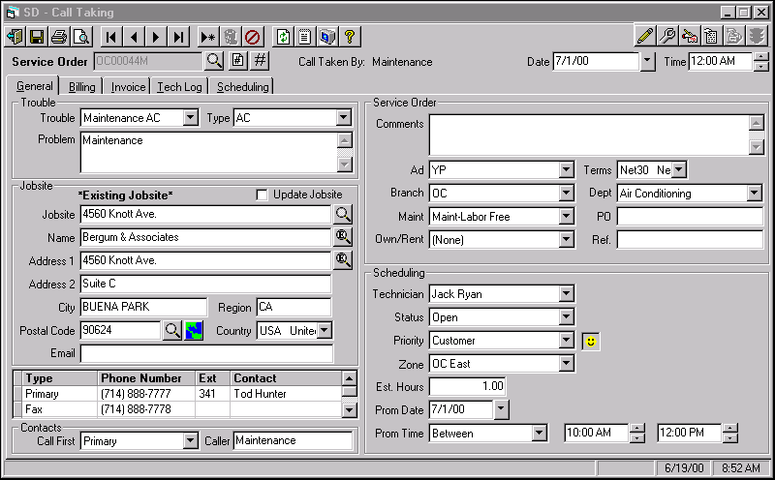
Figure 6 - Service Dispatch Setup Manual 8-3

Every sales order has a Tax Group ID that is on the Call Taking / Billing tab.
      - The Tax Group ID is setup in Traverse and will determine the accounts to which sales tax will be posted.
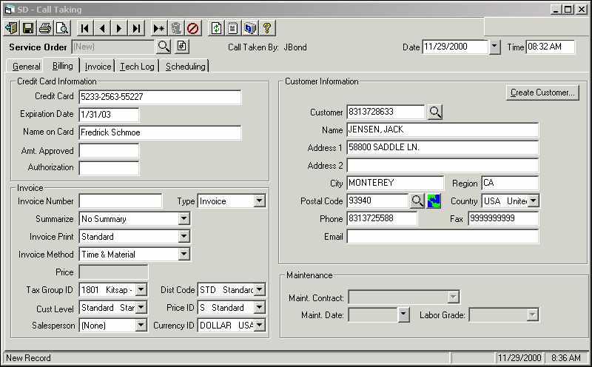
      - The Tax Group ID will default from the Jobsite file for existing jobsites or the Postal file for new jobsites, but it can be changed on the service order.
Figure 7 - Service Dispatch Setup Manual 8-10

Sales & Cost of Goods Sold

Ascente will determine the sales and cost of good sold accounts that are passed to the Traverse.

Remember that there are three segments to a GL account.
    - (1) Main
    - (2) Branch
      - The Branch segment value is determined by the Branch code entered on the service order in the Call Taking / General tab.
    - (3) Department
      - The Department segment value is determined by the Department code entered on the service order in the Call Taking, General tab.
  - All that remains to be determined now is the Main GL segment for sales and COGS.
    - COGS - The base GL account for the COGS is determined by the Bill Type code for each item.
      - This base account number determines the main segment.
      - This base account number will have its Branch and Department segments replaced with the Branch & Department segments determined by the Branch & Department codes entered on the service order.
    - SALES - The base GL account for the sales account is determined by either:
      - The Bill Type record for service orders that are NOT flagged as fixed price.
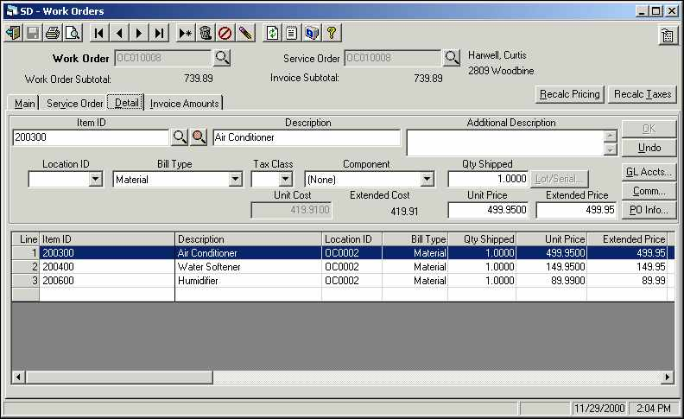
      - The Base Fixed Price GL # from the Department record if the service order is flagged as fixed price.
    - The base account number will now have the branch and the department segments replaced with the segment numbers determined by the Branch and Department codes. These sales and COGS accounts will be passed to Traverse.

Default Bill Type Values
    - For non-stocked items the Bill Type will default based on the Ascente/ Maintenance/ Options and Interfaces/ Work Order tab’s Non-Stock Bill Type.
    - For all stocked items the Bill Type will default based on the Traverse Product Line that all Item ID’s will reference.
      - Ascente has a Bill Type Cross Reference file that is where Traverse Product Lines records are assigned to Ascente Bill Type records.
        - When the Product Line exists in the Ascente, Bill Type Cross Reference file, the Bill Type for the item is determined.
        - When the Product Line does not exist in the Ascente, Bill Type Cross Reference file, the Bill Type will default based on the Ascente/ Maintenance/ Options and Interfaces/ Work Order tab’s Non-Stock Bill Type.

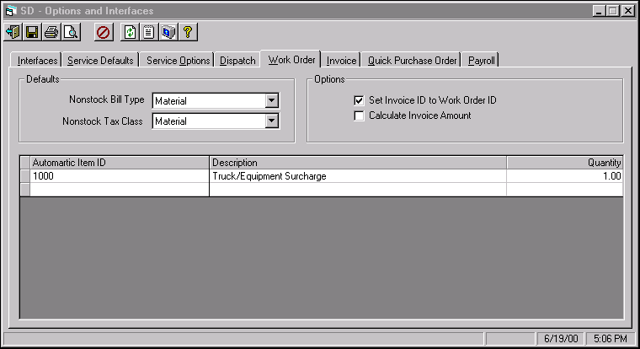
Ascente/ Maintenance/ Options and Interfaces/ Work Order tab
Figure 9 - Service Dispatch Setup Manual 15 - 10

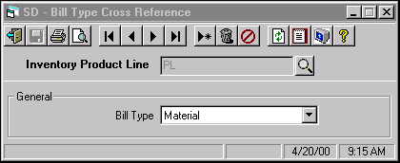
Figure 10 - Service Dispatch Setup Manual 5 - 2
- Inventory Account Logic
  - Traverse will determine the inventory account that Ascente will pass to Traverse.
    - Non-stock Items
      - The Traverse/ Sales Order/ Setup and Maintenance/ Options and Interfaces/ Default tab has a Default Inventory account that will be used for all non-stocked items.

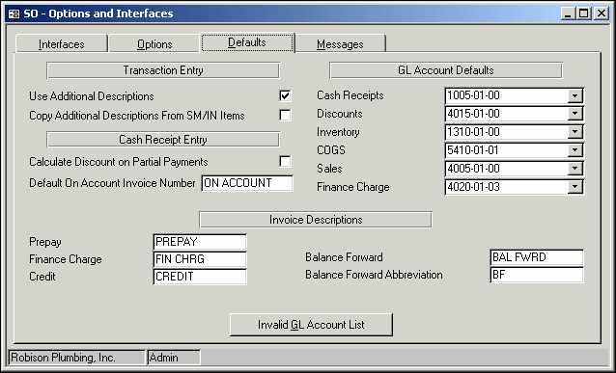
Figure 11 - Traverse/ Sales Order/ Setup and Maintenance/ Options and Interfaces/ Default tab

    - Stocked Items
      - The stocked item will have an Item Location record in Traverse/ Inventory/ Setup and Maintenance/ Item Locations file.
      - The Item Location record will reference an Account Code record in the Traverse/ Inventory/ Setup and Maintenance/ Account Codes file.

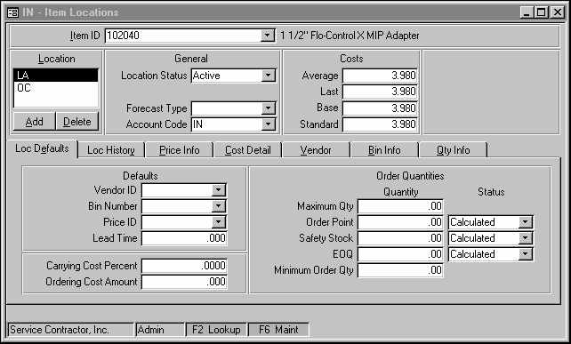
Figure 12 - Traverse/ Sales Order/ Setup and Maintenance/ Options and Interfaces/ Default tab

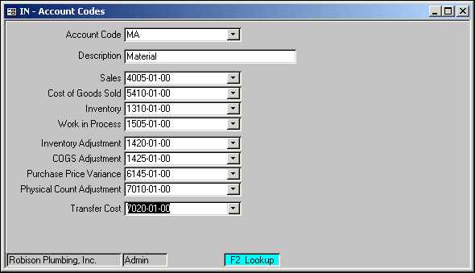
      - The Account code record has the inventory account that will be used for this stocked item.
Figure 13 - Traverse/ Setup and Maintenance / Account Codes

- Sales Tax Account Logic

Every sales order has a Tax Group ID that is on the Call Taking/Billing tab.
    - The Tax Group ID is setup in Traverse and will determine the sales tax account that will be posted to.
    - The Traverse Tax Group ID will default from the jobsite file, but it can be changed on the service order.

- Use Tax Logic
  - Traverse does not track use tax at this time.
    - Ascente does calculate use tax but this does not result in any general ledger postings that are passed to the Traverse.
    - An Ascente Sales and Use Tax Report can be printed to show the sales tax and use tax calculated by the Ascente, Work Order Entry program. This Sales and Use Tax Report runs off of history records that are created by the Invoice Update process.
    - A journal can be manually entered into the Traverse system to account for the use tax. This would commonly be a debit to a COGS account and a credit to a sales tax payable account.

- Cash Account Logic
  - In the Work Order Entry/ Invoice Amounts tab there is a MethodID field where you indicate the payment method. This field only accepts Traverse Payment Method Codes that are setup in the Traverse/ Accounts Receivable/ Setup and Maintenance/ Payment Methods file.
  - The Payment Methods file reverences a Bank Account ID record.
  - The Bank Account ID record references the General Ledger Cash Account that will be posted to.
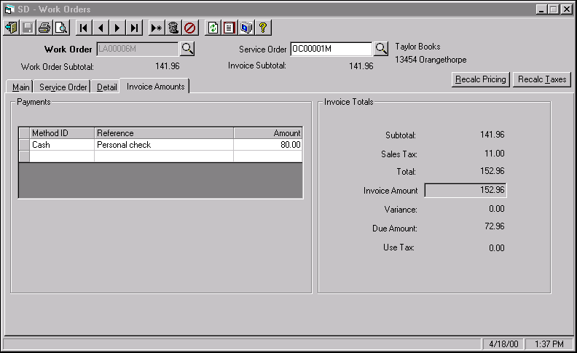

Figure 14 – Ascente / Transactions / Work Order Entry /Invoice Amount Tab

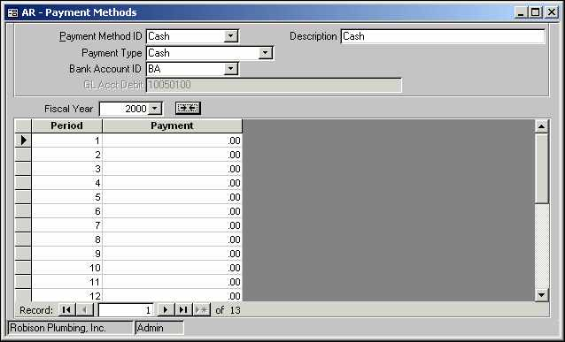
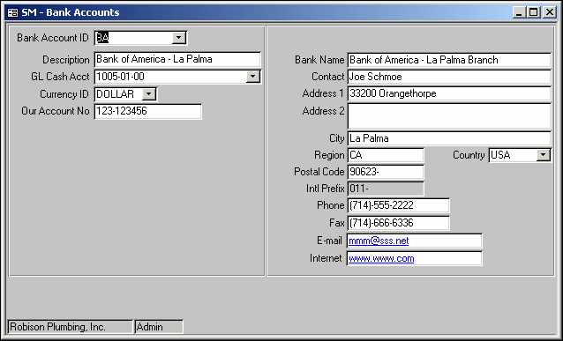
Figure 15 – Traverse / Accounts Receivable / Setup & Maintenance / Payment Methods.
Figure 16 – Traverse / System Manager / Setup & Maintenance / Bank Accounts

- Accounts Receivable GL Account Logic
  - In the Ascente every service order that is billed will reference a Traverse customer record. This can be seen in the Call Taking, Billing Tab in the Customer field.
  - Every Traverse customer record references a Traverse/Accounts Receivable/ Setup and Maintenance/ Distribution Code record.
  - The Traverse Distribution Code record will determine the receivables account that will be posted too as a result of the Ascente Invoicing Cycle.

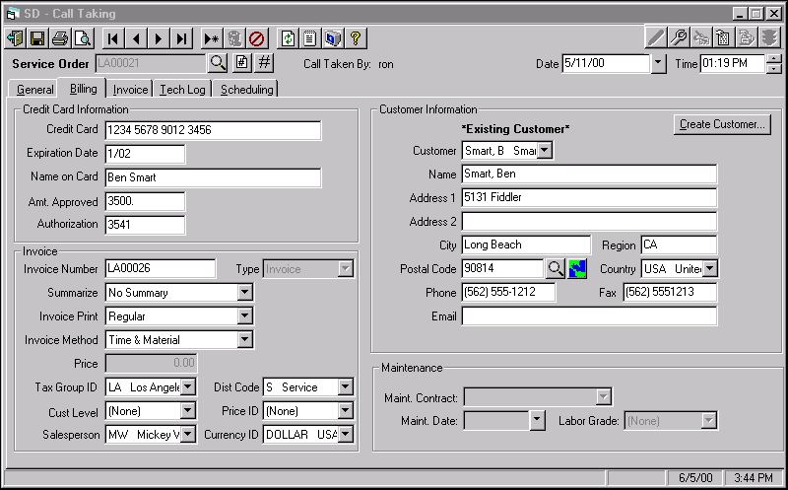
Figure 17 – Ascente / Transactions / Call Taking / Billing tab

ASCENTE SALES & COGS GL ACCOUNT LOGIC
Base Account # → | Main  Segment | Branch  Segment | Department Segment
Base Account # → | 4100 | 01 | 03
COGS: The base account number for the COGS is determined by the Bill Type code.  SALES: The base account # for sales is determined by the Bill Type record or the Base Fixed Price GL # from the Department record if the service order is flagged as a fixed price job. | The base account number’s main segment is used as the main segment for the calculated account number. | The initial branch segment to the base account # 01 is overlaid by the branch code assigned to the service order 03. | The initial department segment to the base account # 03 is determined by the department code assigned to the service order 02.
Main Segment | 4100
Branch Code |  | 03
Department Code |  |  | 02
Calculated Account # | 4100 | 03 | 02
This chart demonstrates how the initial base account number has the branch and department segments overlaid to determine the calculated account # that will be posted to the Traverse GL System.

ASCENTE POSTING CHART
Posting Type | Posting Determined by |  | Notes
Posting Type | Ascente | Traverse | Notes
Cash |  | X | Payment Method Code
Inventory |  | X | IC Account Code or Default from Control File
Accounts Receivable |  | X | AR Distribution Code
Sales Tax |  | X | SM Tax Group ID
Sales | X |  | Bill Type or FP Acct from Dept file
Cost of Goods Sold | X | X | Stocked = Bill Type or NS = Control File
This chart assumes that the Traverse GL Method is not being used. See the Ascente / Maintenance / Options and Interfaces program in the Invoice tab.

SERVICE ORDER / INVOICE PROCESSING CYCLE

ASCENTE PROCESSING
Menu Selection | Results
Transactions / Call Taking | This is where the initial service order is entered.
Transactions / Work Orders | This is where the labor, material and flatrate tasks are entered.
Journals / Prebill Register | This process performs three functions:  - A Prebill Register Report is printed. This is used to verify that the entry is correct. (Report)  - Printing the invoices.  - Updating the transactions listed on the Prebill and transferring the information to the Traverse System. (Update)

TRAVERSE PROCESSING CYCLE
Menu Selection | Results
Accounts Receivable / Transaction Journals /  Sales Journal | This prints the Sales Journal Report.  (Report)
Accounts Receivable / Transaction Journals /  Miscellaneous Credits Journal | This report serves as an audit trail.  (Report)
Accounts Receivable / Transaction Journals /  Daily Sales Tax Journal | The Daily Sales Tax Journal shows taxes collected and calculated and is organized by tax location.  (Report)
Accounts Receivable / Transaction Journals /  Cash Receipts Journal | The Cash Receipts Journal provides a record of the cash receipts in transactions. Produce the journal before you post the cash receipts for the day.  (Report)
Accounts Receivable / Transaction Journals /  Methods of Payment Journal | The Methods of Payment Journal summarizes cash receipts by methods of payment. Use this function to produce a list of receipts for credit card claims, checks, and other methods of payment.  (Report)
Accounts Receivable / Transaction Journals /  Deposits Journal | The Deposits Journal summarizes and lists bank deposits from cash and check receipts.  (Report)
Accounts Receivable / Transaction Journals /  Post Transactions | This process completes the processing cycle. This will create the Traverse records for the General Ledger System and also for the Accounts Receivable System.  (Update)

This assumes the Ascente/Maintenance/Options and Interface/Invoice tab; Use Traverse GL Method is NOT selected.

