Service Dispatch
Jobsite Component Basics
September 2017

Table of Contents
Overview 1
What Parts Do We Add Components For? 1
Jobsite, Component and Maintenance Contract Relationships 1
Building Your Component Database 2
Adding Component Records 2
Ascente Mobile Pro 2
Ascente: Jobsite Component File Maintenance 3
Ascente: Work Order 3
Inventory – Part Maintenance 4
Operations 5
Component Service Tracking: Work Order or Detail Item Level 5
Work Order Level 5
Detail Item Level 5
Recommendation 6
Ascente: Work Order [Main] tab 6
Ascente: Work Order [Detail] tab 7
Reports and Inquiries 8
Service Order History Inquiry 8
Tasking Service Order 8
Component Listing 9
Final Recommendations 10

Overview
Components records in Ascente are used for accumulating relevant information for a major mechanical component at the jobsites you service such as HVAC units, condensers or water heaters. The information includes the following:
- Manufacturer
- Model #
- Serial #
- Warranty & Installation Date
- Capacity
- Maintenance Contracts this component is covered by
- Developing maintenance schedule and Tasking for a component.

Components make possible the following:
- Tracking service history and costs by component.
- Providing maintenance history by component.
- Marketing based on component install & warranty dates.
- Optionally providing component information on your invoice forms for the components serviced.
This document will discuss how Jobsite Component records are created and maintained in Ascente. These are also referred to as Local ID’s or Equipment records by some companies. All components will reference an existing jobsite record (service location). A jobsite can have multiple components linked to the jobsite. These are used to manage and track major mechanical components that are installed and maintained and possibly covered under a maintenance contract. In the HVAC industry more and more, it is becoming a requirement to be able to provide maintenance and service history by component as opposed to just by jobsite.
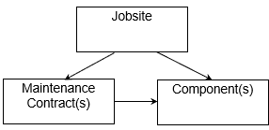

What Parts Do We Add Components For?
Component records will should to be created as necessary for major components. This is a judgement call by companies regarding what is a major component. You could create a component record for every nut, screw and washer, but you do not want to do that. Most companies only do this for major components that have a serial #, warranty and typically something that you or your customers would want to track maintenance on or setup maintenance tasking records for.

Jobsite, Component and Maintenance Contract Relationships
You can see below how a jobsite must exist before you can add a component record because that component must reference a jobsite record. Maintenance contracts that also must link to a jobsite can be linked to a component record when that component is covered by that maintenance contract.

Building Your Component Database
Every company would like to have complete records of all major components at all their jobsites that they service. The challenge is gathering that information and entering it into Ascente. Components can be added and maintained in either Ascente Mobile Pro or Ascente:
- Ascente Mobile Pro software from the field by the technicians on their mobile devices when the technician is onsite installing or servicing a component.
- In the office in Ascente with the information that is gathered and provided by the technician or other source from either the:
  - Ascente: Jobsite Maintenance Program
    - Add the record using the Ascente / Service / Maintenance / Jobsite [Component] program.
  - Ascente: Work Order Entry Program
    - Add a component from the Ascente / Service / Transactions / Transactions / Work Orders program from the [Main] tab and by using the [F6] key from the ‘Component’ field.
    - The component selected will serve as the default component for all subsequent work order line records that are added.
    - Add a component from the Ascente / Service / Transactions / Transactions / Work Orders program from the [Detail] tab and by using the [F6] key from the ‘Component’ field.
  - Ascente: Inventory - Part Maintenance
    - You can setup an Ascente / Inventory / Maintenance / Part Maintenance program and setting the [Auto Add Component] flag so that when the part is invoiced, a new component record for the part and jobsite will be created when the work order is invoiced.

Adding Component Records

Ascente Mobile Pro
With Ascente Mobile Pro, from the field the technicians can see existing components for the jobsite or add new component records. They can also indicate the component(s) being serviced.
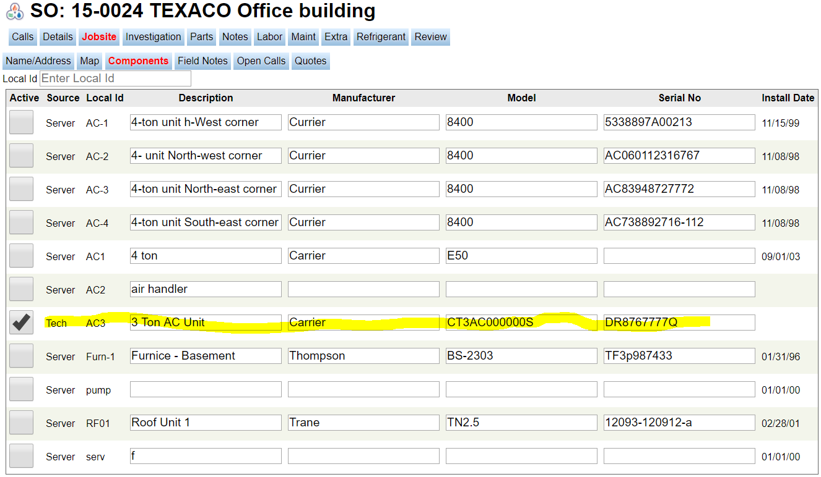
New components can be added here.
Figure 1: This is the form in Ascente Mobile Pro where the components can be added from the field.

Ascente: Jobsite Component File Maintenance
The component records in Ascente include the following information:
- General [Tab]
  - Description
  - Model #
  - Manufacturer
  - Serial #
  - Maintenance Contract #
  - Installation Date
  - Warranty Date
  - Refrigerant Requirements
  - Unit Capacity Details
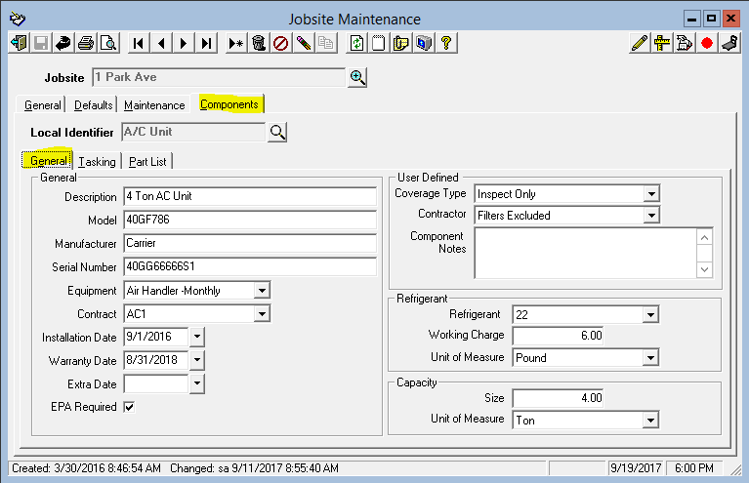
Figure 2: Ascente / Service / Maintenance / Jobsite [Component] tab

Ascente: Work Order
Component records can be added from the Ascente / Service / Transaction / Work Order program from either the [Main] or [Detail] tabs by using the [F6] function key from the component fields.

Inventory – Part Maintenance
The Inventory – Part records can be setup to automatically create a Jobsite Component record.
- Auto Add Component: Check this box if you want the system to automatically create a Jobsite Component record when you sell this part on a Work Order. The Jobsite Component record will be created when the Work Order is billed on a Prebill update. Note that this can be overridden on the Work Order.
- Component Abbreviation: This value will be used as the Component ID when a Jobsite Component is created from the Part. If a Component already exists with this value, a number will be appended to the end, starting with 1 and incrementing by 1 (ie, AC UNIT, AC UNIT1, AC UNIT2). This can be up to 10 characters. If left blank, the system will use the Component Abbreviation set up in Options & Interfaces (Inventory).
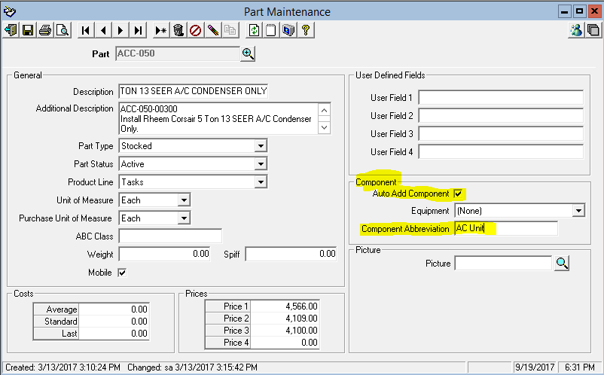
Figure 3: Inventory / Maintenance / Part is used to maintain inventory part records and the 'Auto Add Component' field.

Operations

Component Service Tracking: Work Order or Detail Item Level
At what level of detail do you want to track component service sales, costs and history? In Ascente you can have either:
- One component assigned to a work order and have all the detail work order line(s) reference that one component.
- No component assigned to the work order, but every work order line can reference a different component.

Work Order Level
This level is almost always used and is recommended. It is assumed that the service provided is only for one component. All labor and material costs reference that one component.

Advantages
- Ease of operation and entry.
- Service History records will reference the component serviced.

Disadvantages
- If multiple major components are serviced, the history will only reference one component.
- You can create a separate service order for each component.
Service Order | Work Order | Work Order Component | Work Order Line | Part | Work Order Line Component | Qty | Cost | Sell
S1000 | S1000 | AC01 | 1 | Labor | AC01 | 1 | 30 | 80
S1000 | S1000 | AC01 | 2 | R22 | AC01 | 5 | 200 | 400
S1000 | S1000 | AC01 | 3 | Belt | AC01 | 1 | 8 | 18
Figure 4: Examples of assigning the component at the Work Order Level

Detail Item Level
This level assumes that you are servicing multiple components on one service order and the work order lines will not all reference the same component.

Advantages
- You do not have to create a separate service order for each component.

Disadvantages
- The service order history will reference one component, but multiple components were actual serviced.
- Operationally it is more work because every work order line will need to reference the correct component.
- While labor is posted in total for the service, it may might need to be spread between multiple components and will not be correct without a lot of manual entries.
Service Order | Work Order | Work Order Component | Work Order Line | Part | Work Order Line Component | Qty | Cost | Sell
S1002 | S1002 |  | 1 | Labor | AC02 | 1 | 3 | 80
S1002 | S1002 |  | 2 | R22 | AC03 | 5 | 20 | 400
S1002 | S1002 |  | 3 | Belt | AC04 | 1 | 8 | 18
Figure 5: Examples of tagging a work order and detail lines with component(s). Note the top has the same component

Recommendation
In almost all cases we recommend assigning components at the service order/work order level as opposed to the assigning multiple components on a single work order at the detail item level.

Ascente: Work Order [Main] tab
This is where you can enter the component for this work order when tracking components at the work order level. The component records in Ascente include the following information:
- General [Tab]
  - Component
  - Select an existing component record
  - Use the [F6] function key to add a new component record
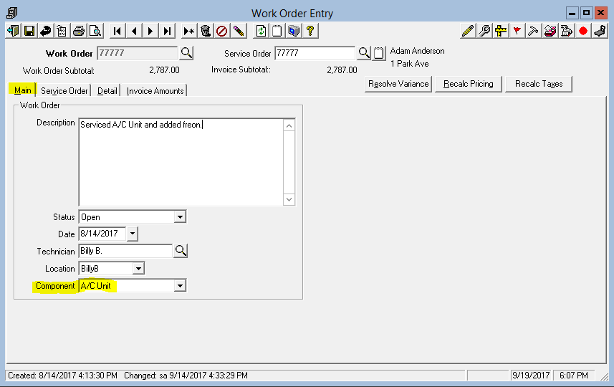
Figure 6: Work Order [Main] tab is used to set the component default for this work order.

Ascente: Work Order [Detail] tab
This is where you can enter the component for each work order detail line. This is done when tracking components at the detail item level. The component records in Ascente include the following information:
- Detail [tab]
  - Component
  - From each work order detail line record, you can assign or remove a component that the work order line item referenced.
  - Use the [F6] function key to add a new component record
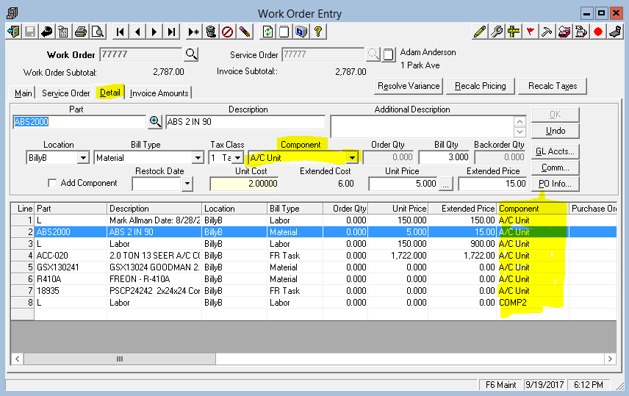
Figure 7: Work Order [Main] tab is used to set the component default.

Reports and Inquiries

Service Order History Inquiry
The Service Order History Inquiry can include the component code assigned to the work order.
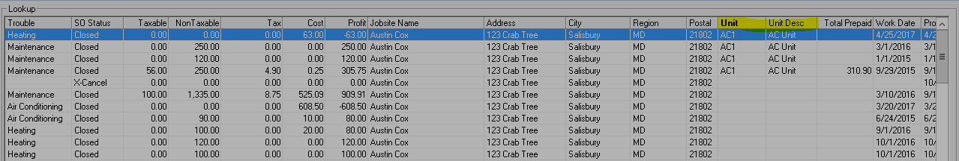
Figure 8: Service Order History Inquiry. Note the component code included in the 'Unit' column.

Tasking Service Order
There is a ‘Tasking Service Order’ that can be printed that will reference the components being services for a maintenance service order.
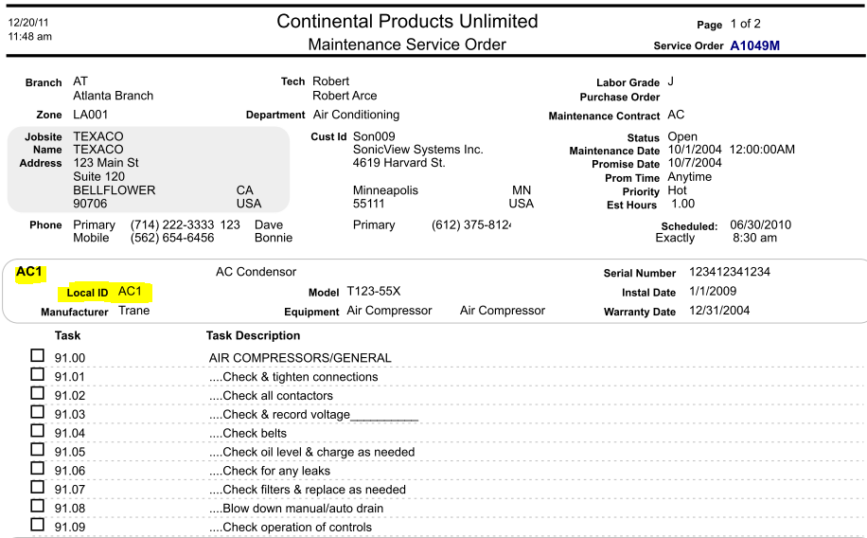
Figure 9: Tasking Service Order: Ascente / Service / Reports / Service Order Print [ Tasking Service order]

Component Listing
The Component Listing Report can be run to list component records based on many different combinations of runtime criteria. Examples of uses are:
- List components by an install date or warranty date range for marketing.
- List all components by a manufacturer for warranty tracking purposes.
- Listing all installations of a specific modem #.
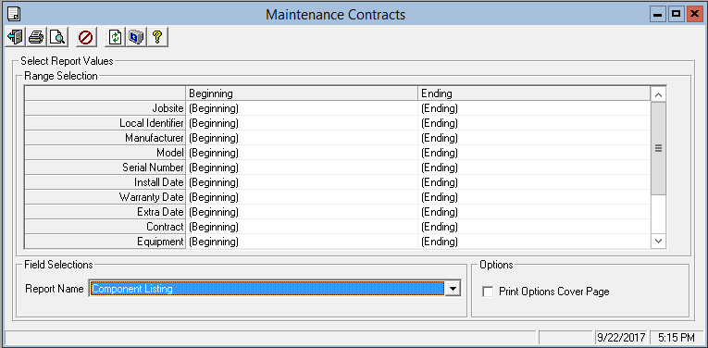
Figure 10: The Ascente / Service / Reports / Maintenance Contracts / Component Listing – Runtime Options

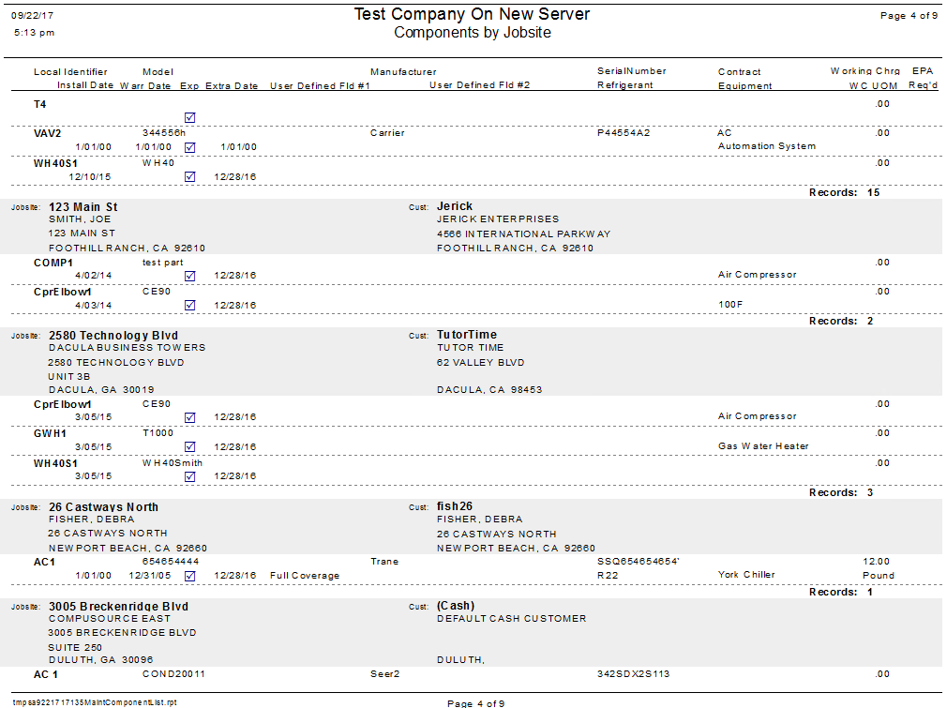
Figure 11: The Ascente / Service / Reports / Maintenance Contracts / Component Listing Report

Final Recommendations
- You may want to consider using components if you work in the HVAC and particularly if you have commercial maintenance contracts on major components.
- Would history by component be valuable to you or your customers?
- You may also want to consider looking at the Ascente – Tasking module for creating predetermined maintenance schedules unique to each component.
- Ascente Mobile Pro will make it easier to build your component records for your jobsites because the technician can do this from the field as opposed to capturing the information and then having the office enter the component records later.

