

Inventory Quantity Tracking

Webinar

April 2012



Table of Contents

Overview 1

Assumptions 1

Using the Physical Inventory Process to Load your Quantities 2

Purpose 2

Overview 2

Assumptions 2

Examples 3

What Is The Current Value Of My Inventory? 4

Physical Inventory Process 5

Step #1 – Freeze Quantities 6

Step #2 – Print Inventory Tags/Worksheets 7

Step #3 – Physical Counts Worksheet Entry 8

Step #4 – Physical Counts List 9

Step #5 – Variance Report 10

Step #6 – Physical Counts Valuation Report 11

Step #7 – Update Perpetual Inventory 12

General Ledger Postings 13

Inventory – Account Codes 14

Recommendations 14

How to enter Transfers\Adjustments 15

Assumptions 15

Inventory Transfers 15

Inventory Adjustments 16

Review of Which Processes Automatically Adjust Inventory Quantities 18

Using the Work Order Restock Option 19

Purpose 19

Assumptions 19

From Location 19

To Location 19

Bin Number 19

Restock Date 19

Procedure for Work Order Restock Register 19

Requirements 19

Processing Steps 20

Using the Inventory Movement Report to See Your Transactions 21

# Overview

Congratulations, you have developed your inventory item database in Traverse. You have now attained what we refer to as *level 2* of inventory implementation. That means that you are using item numbers, but not tracking quantities on any of your trucks or your shop.

This document and webinar will explain the steps and processes required get to *level 3* of inventory implementation, tracking quantity levels on your trucks and shop. Specifically we will discuss the following:

* Using the Physical Inventory process to load your quantities
* How to enter Transfers\Adjustments
* A review of which processes automatically adjust inventory quantities
* Using the Work Order Restock option
* Using the Inventory Movement Report to see your transactions

# Assumptions

* You have access to Traverse and the necessary security privileges to run all of the programs required to setup and maintain the Traverse – Inventory Module.
* You will sometimes see or hear references to items, item numbers, parts or part numbers. They all refer to the same thing. These are just codes used in the inventory module to reference item records setup in the Traverse / Inventory / Setup and Maintenance / Item program.
* Your inventory items have already been defined in the Traverse – Inventory module and all items to be tracked are flagged with an *‘Item Type*’ of ‘*NonSerialized’*.
* I am assuming that you have either attended or watched these previous webinars:
  + Should I Be Tracking Inventory Levels
  + Inventory Webinar - Inventory Setup
    - These recorded webinars can be viewed at any time from our website <www.compusource.com>. We will be glad to provide you with the documentation for these webinars upon your request.
* This webinar will not detail all of the steps necessary to do the following processes in Ascente and Traverse, but you will need to fully implement the following modules and processes before attempting to implement quantity tracking.
  + Purchasing
    - Ordering
    - Receiving
  + Order Entry
    - Work Order
    - Inventory to Job
  + Restocking
    - Shop
    - Trucks
  + Processing Returns
  + Physical Inventory
    - Load opening balances

# Using the Physical Inventory Process to Load your Quantities

The Traverse – Physical Inventory module is used to load your inventory counts. The process basically will tell you the quantity levels Traverse thinks you have, you will tell Traverse what the actual counts are, and then you will get reports that will tell you what the differences are and once the batches are posted, the Traverse counts will be the same as the actual counts you entered.

## Purpose

The Traverse Physical Inventory process is used to enter your actual counted quantities of your inventory items by location. This process will correct any variances between what the system thinks you have and what you actually have. The items are typically counted and entered during the same day.

## Overview

The Physical Inventory process will result in the following once completed:

* The on-hand item quantities will be adjusted up or down by the difference between the frozen quantity and the physical counts you entered.
* The general ledger posting can result if general ledger is interfaced that will result in an adjustment based on the value of the difference.

## Assumptions

* All items to be counted are already entered into the Traverse Item file.
* All items are assigned to each location that they are tracked at.
* The cost used as your cost basis, typically average cost, is entered for each Item Location record is correct. This will be used to calculate the value of the inventory and the general ledger posting amounts for the variance.
* The Account Codes assigned to every Item Location record are correct. This will determine the general ledger accounts to be posted to for the amount of the variance.

### Examples

The examples in this document are for only one item *HON1000* in location *Main*. You will see the on-hand quantity and value before and after the physical inventory count is entered.

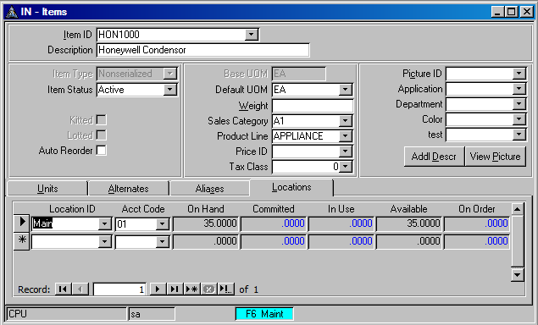

1

2

Figure 1: Inventory / Setup and Maintenance / Items Screen

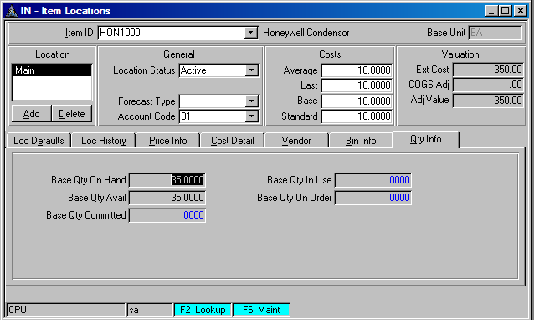

3

Figure 2: Inventory / Setup and Maintenance / Item Locations Screen

1. Item ID = HON1000
2. Location = **Main** and Acct Code = **01**
3. The costing method used is average cost and the average cost for item HON1000 at location Main is **$10.00**.

## What Is The Current Value Of My Inventory?

You can optionally print the Traverse / Inventory / Reports / Valuation Report to determine the current value of your inventory prior to loading the counts from your physical inventory.

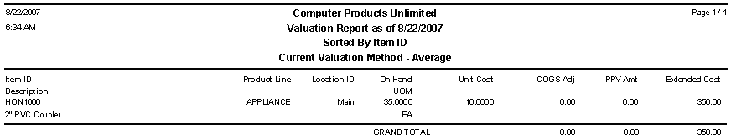

Figure 3: Traverse / Inventory / Reports / Valuation Report

* You can see that the value of the inventory selected for this report is $350.00.
* The calculation is UNIT COST x ON-HAND QTY = INVENTORY VALUE
* 35 x $10.00 = $350.00

## Physical Inventory Process

There are many different options that can be used in this process. I highly recommend that you use the specific options and steps as detailed.

It is important to note that this is a batch process. This means that you can prepare a batch for just one truck or only one product line of items on a truck. It is recommended that you do small batches instead of one huge batch for all trucks and product lines. You might want to try the process for just one item at one location the forst time to become comfortable with the process.

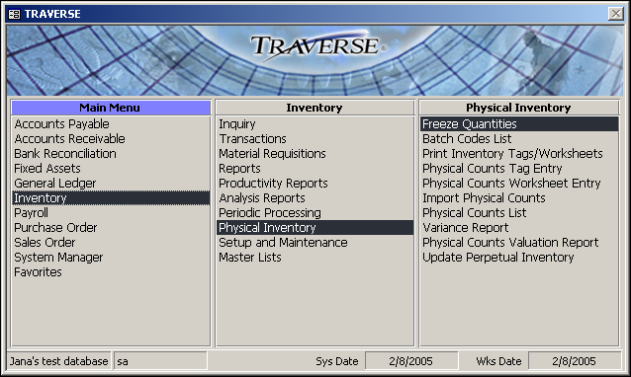

Use the Freeze Quantities function to create a batch which will include the items to be counted. The process will capture the on-hand quantities of the items selected at the time the program is run. Do not freeze quantities until you are ready to do the count and enter the counted quantities.

I recommend that you do not attempt to freeze all locations and items in one large batch. You should consider doing a separate batch for each location. You can create a batch based on the following criteria:

* Location
* Item ID
* Bin
* Product Line
* User Defined Field

### Step #1 – Freeze Quantities

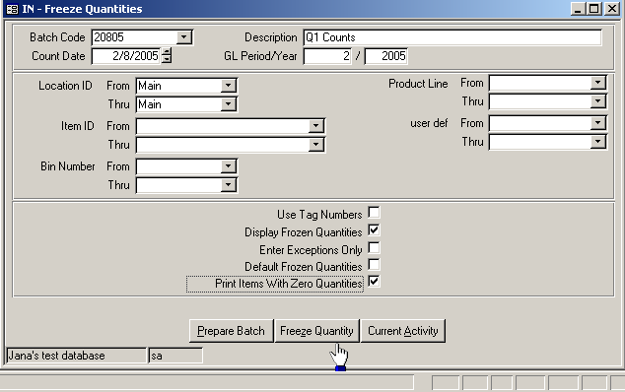

9

8

7

6

5

4

3

2

1

1. To add a new batch code, click the New Record button and enter the batch code. Otherwise, select a prepared batch code for which to freeze quantities.
2. Enter a batch code description. The description can be edited after preparing or freezing the batch.
3. Select the range of Locations to include in the batch or leave blank to include all locations.
4. Optionally, select a range of Item IDs, Bin Numbers, or Product Lines if needed. Leave blank to include all.
5. To display frozen quantities on the Physical Counts Worksheet Entry screen, check the Display Frozen Quantities box.
6. To print zero quantity items on the worksheet, check the Print Items with Zero Quantities box.
7. Click the Prepare Batch button to prepare the physical inventory count records and save the batch.
8. Click the Freeze Quantity button to freeze quantities for the batch. If you are working with a new batch, this button saves, prepares and freezes the batch.
9. Click the Current Activity button to view batch activity information. This will indicate when this process was previously done. This is optional.

### Step #2 – Print Inventory Tags/Worksheets

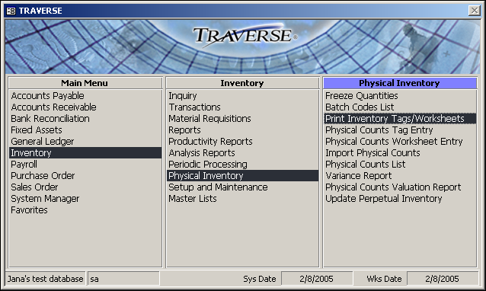

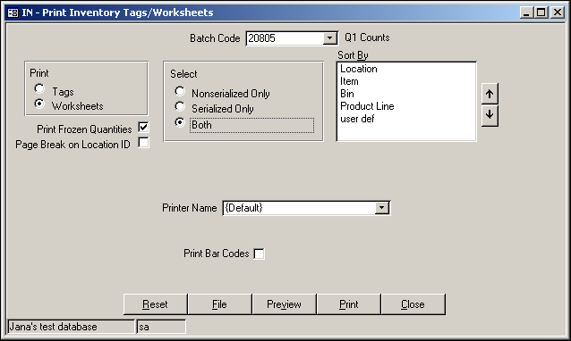

Select ‘Worksheets’.

Typically, you will select both. Ascente does not support serialized items.

Figure 4: Inventory / Physical Inventory / Inventory Tags/Worksheets

The report is intended to be used by the persons doing the count to write the counts on.

### Step #3 – Physical Counts Worksheet Entry

After the counts have been collected, run the Physical Counts Worksheet Entry and enter the counts.

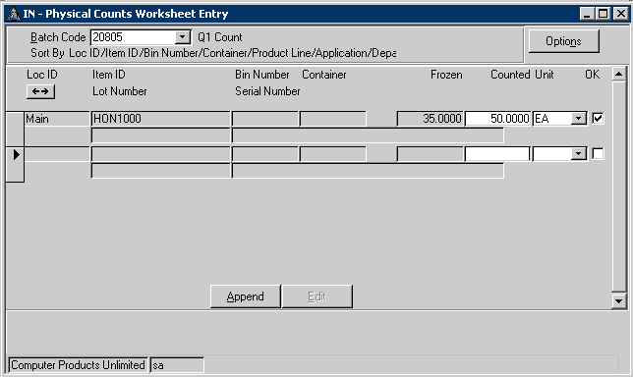

Enter your counted amount for the item here. It the counted amount is zero, still enter zero here.

The ‘OK’ box should be checked once you tab through each line.

Figure 5: Inventory / Physical Inventory / Physical Counts Worksheet Entry

The Append button can be used to add an item to the count that was counted but is not on the Worksheet Entry screen.

### Step #4 – Physical Counts List

After you have entered physical counts, use the Physical Counts List function to produce a list of quantities from selected batches to verify that you have entered the correct quantities.

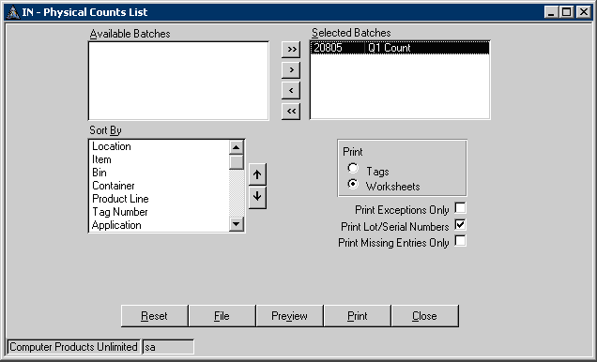

Select ‘Worksheets’.

Figure 6: Inventory / Physical Inventory Physical Counts List

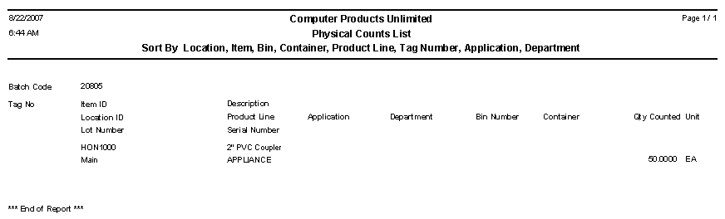

### Step #5 – Variance Report

After you have entered and verified physical counts, use the Variance Report to compare the original frozen quantities to the counted quantities. Variances are expressed as quantities and are based upon your inventory valuation method.

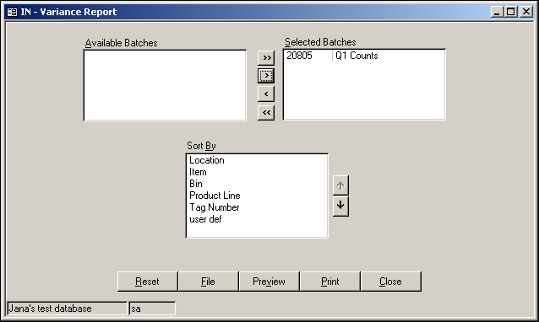

Select the batches you are processing.

Figure 7: Inventory / Physical Inventory / Variance Report

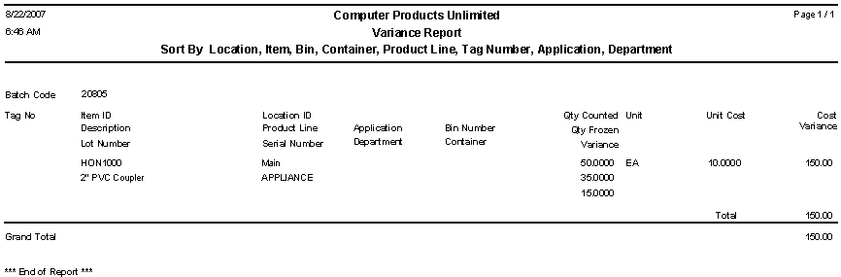

Step #6 – Physical Counts Valuation Report

After you have entered and verified physical counts, use the Physical Counts Valuation Report to detail the items and quantities frozen in each physical count batch, the value of those items before and after the physical count, and the variance, if any.

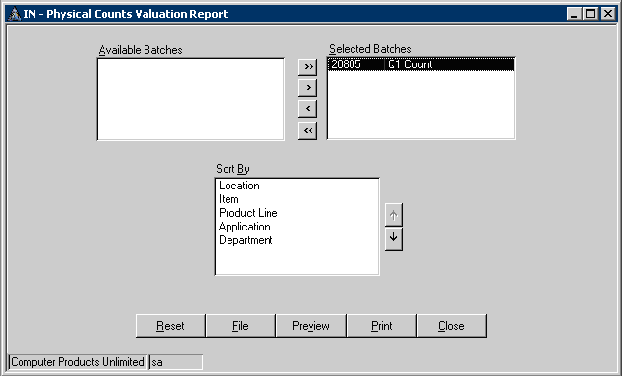

Select the batches you are processing.

Figure 8: Inventory / Physical Inventory / Physical Counts Valuation Report

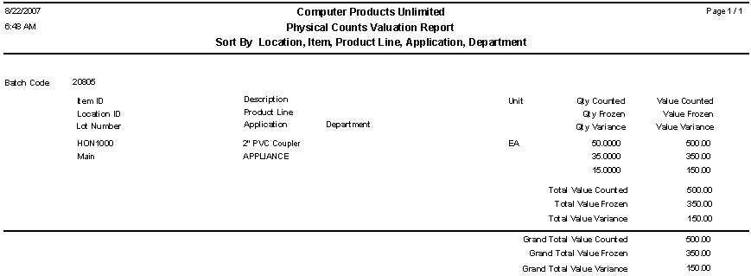

***IMPORTANT****: You should not proceed to the next step of running the Update Perpetual Inventory if the counts entered on these reports are not correct.*

### Step #7 – Update Perpetual Inventory

The Update Perpetual Inventory program should not be run until all of the counts and values have been entered and verified on reports that were run in the previous steps. This will update the system with the new counts and optionally update the general ledger by the variance dollar amount.

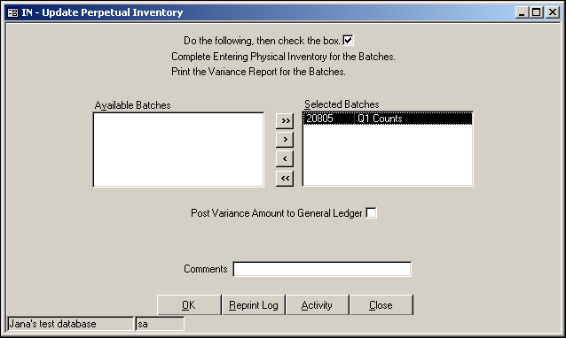

4

3

2

1

Figure 9: Inventory / Physical Inventory / Update Perpetual Inventory

1. Select the batches for which you want to update perpetual inventory.
2. To post the variance amount in General Ledger, select the check box; otherwise, clear the check box. This option is available only if you interface Inventory with General Ledger in the Options and Interfaces function. You should probably review this with your accountant if you are unsure.
3. Enter comments for the post to General Ledger. Example: *Load Q1 PI Counts*
4. Click OK to begin processing. A message appears if you select batches that are in use or locked. Click OK to close this message box.
5. When the post completes successfully, a confirmation box appears. Click OK and the Update Perpetual Inventory Log dialog box appears. Select how you want to output the report.

**Computer Products Unlimited**

**Update Perpetual Inventory - Post Log**

**Item ID** **Location ID** **GL Account** **Debit** **Credit**

**Batch Code** 20805

HON1000 Main 00-00-1230 150.00

HON1000 Main 00-00-1290 150.00

**Posted to Year/Period** **2005/2** 150.00 150.

**Grand Total 150.00 150.00**

The counts have now been updated.

### General Ledger Postings

If the General Ledger module is interfaced with the Inventory module and if when running the Update Perpetual Inventory program, the runtime option to ‘Post Variance Amount to General Ledger’ is checked, a journal will be created that will adjust the inventory and an inventory variance for the amount of the variance.

The general ledger accounts are determined by the Account Codes that are assigned to each Item Location record, see the example on page 2 and you will see that account code ‘01’ is assigned to item ‘HON1000’ at location ‘Main’.

The variance amounts are based on the inventory valuation method you use. If you use the LIFO or the FIFO method and no cost is available (for example, because the item has no on-hand quantity), the system updates the COGS adjustment amounts by the average cost of the item.

Variance: increase in inventory:

2

1

|  |  |  |  |  |
| --- | --- | --- | --- | --- |
| IN Adjustment | |  | Physical Count Adjustment | |
| DB |  |  |  | CR |
|  |  |  |  |  |

Variance: decrease in inventory:

2

1

|  |  |  |  |  |
| --- | --- | --- | --- | --- |
| IN Adjustment | |  | Physical Count Adjustment | |
|  | CR |  | DB |  |
|  |  |  |  |  |

### Inventory – Account Codes

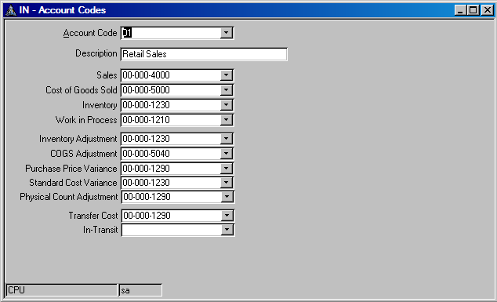

1

2

**Figure 10: Inventory / Setup and Maintenance / Account Codes**

The accounts codes are assigned to every Item Location record. *See page #2.*

### Recommendations

* Verify that all items are setup that you want to track and count.
* Verify that your account codes are setup and assigned correctly before starting the physical inventory process.
* Verify that the *costing method* selected in the Traverse / System Manager / Business Rules – Inventory section is correct. Talk to your accountant if you are not sure.
* Verify that the *cost values* in the Item Location records are correct.
* Do not freeze every location and item in one large batch. Do it in smaller batches. Consider doing one location and/or product line at a time.
* If none are counted, then enter a value of zero in the Physical Counts Entry program.
* Always verify the counts entered on the reports before running the Update Perpetual Inventory program.

# How to enter Transfers\Adjustments

You will need to know how to process transfers in Traverse in order to move item quantities between inventory locations. An example of this would be for restocking a truck with items from the shop that will be transferred to their truck.

You will need to know how to enter adjustments to adjust the on-hand quantities at an inventory location. An example of this could be that the system indicates that there are 10 of an item on a truck, but you have counted only 9. You would enter an adjustment of -1 for that item at that location.

## Assumptions

The items must exist in the Traverse – Inventory – Item table and also must exist at the inventory location being adjusted or transferred from.

## Inventory Transfers

Transfers are done in Traverse using the Traverse / Inventory / Transactions / Inventory Transfers program. These are typically done to restock a truck from the shop or to move items between locations.

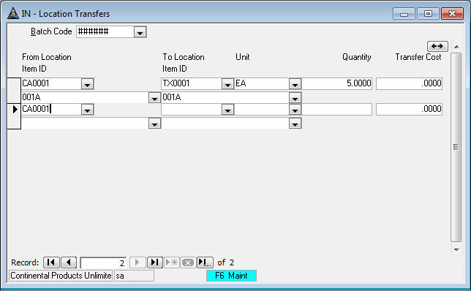

Figure 11: Traverse - Inventory - Locations Transfers Screen

The entry above demonstrates how you can transfer a quantity of 5 of item 001A from location CA0001 to location TX001. The actual transfer is not complete yet you will need to complete the following in order to complete the transfer:

* Traverse / Inventory / Transactions / Transfers Journal
  + Review Entries
* Traverse / Inventory / Transactions / Post Transactions
  + The items transferred will now be transferred between the locations.

## Inventory Adjustments

Adjustments are typically done to adjust for variations between the quantities that Traverse has and the actual quantities at a location. For example, the Inventory – Price and Availability Inquiry below indicates that location MD0001 has 10 of item 001A on hand. You only counted 8 on his truck that you just counted. You would want to do an inventory adjustment to decrease his location MD0001 by 2.

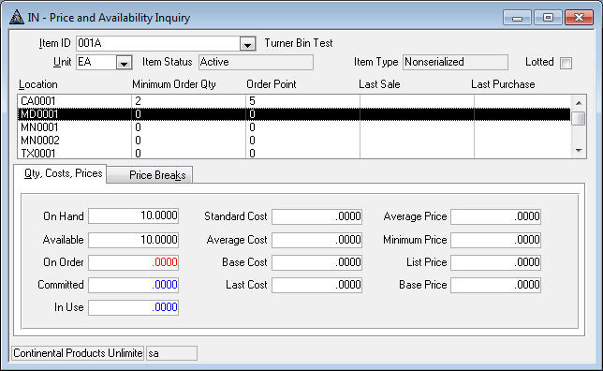

Figure 12: Inventory / Inquiry / Price and Availability Inquiry. I recommend that everyone becomes familiar with this that wants to track quantities.

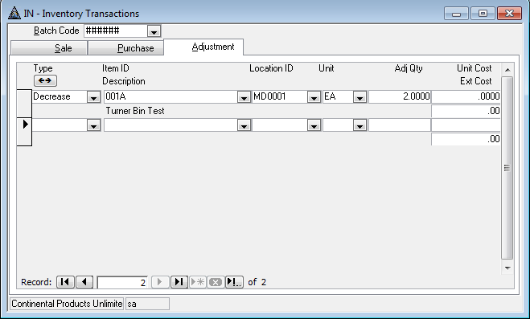

Figure 13: Inventory - Transactions [Adjustments] tab

The actual adjustment is not complete yet you will need to complete the following in order to complete the transfer:

* Traverse / Inventory / Transactions / Transaction Journal
  + Review Entries
* Traverse / Inventory / Transactions / Post Transactions
  + The item adjustments will now be made for the item 001A at location MD0001 to reduce the on-hand quantity of 10 by 2 so that a final on-hand quantity of 8 exists.

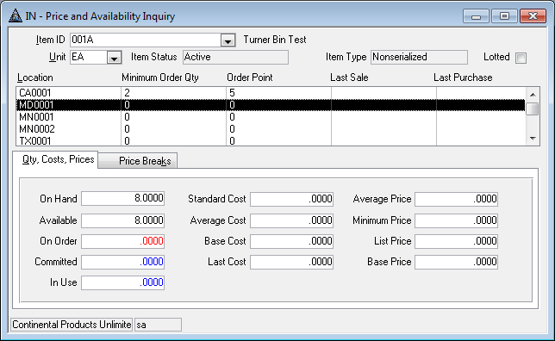

Figure 14: Inventory / Inquiry / Price and Availability Inquiry. Note that the On Hand quantity was reduced by 2 and is now at 8.

# Review of Which Processes Automatically Adjust Inventory Quantities

The following Ascente processed will affect the quantities of the inventory items:

|  |  |  |  |  |  |  |  |  |
| --- | --- | --- | --- | --- | --- | --- | --- | --- |
| **Application** | **Module** | **Program** | **Action** | **In Use** | **On Hand** | **On Order** | **Available** | **Comments** |
| Ascente | Service Dispatch | Work Order | Enter Item | + |  |  | - |  |
| Ascente | Service Dispatch | Work Order | Quick PO |  |  |  |  | No effect on quantities. |
| Ascente | Service Dispatch | Prebill Register | Update |  |  |  |  | No effect, moves Batch transactions to Traverse |
| Ascente | Service Dispatch / Job Cost | Purchase Order | Order Item |  |  | + |  |  |
| Traverse | Purchase Order | Transactions | PO Receipt |  | + | - |  |  |
| Ascente | Job Cost | Inventory to Job | Entry | + |  |  | - |  |
| Ascente | Job Cost | Inventory to Job Register | Update | - | - |  |  |  |
| Traverse | Accounts Receivable | Post Transactions | Update | - | - |  |  | This is true for service or job cost billings. |
| Traverse | Accounts Payable | Transactions | Entry |  | + |  | + | If interfaced in the Traverse Business Rules |
| Traverse | Accounts Payable | Transaction Journals | Post Transactions |  |  |  |  | No Change |
| Traverse | Accounts Receivable | Transaction | Entry | + |  |  | - |  |
| Traverse | Accounts Receivable | Transaction Journals | Post Transactions | - | - |  |  |  |

Figure 15: Ascente and Traverse processes that affect inventory quantities.

# Using the Work Order Restock Option

## Purpose

C:\Users\mka\AppData\Local\Microsoft\Windows\Temporary Internet Files\Content.IE5\8TL68AZY\MC900078625[1].wmfThe purpose of the Work Order Restock Register is to provide a listing of all items from work orders that need to be restocked. The listing will be used to pull the parts to be transferred from the shop to the truck. Once the Work Order Restock Register is printed, it can be updated. The update will flag every listed work order item as restocked so that it will not print on the Work Order Restock Register again so you do not transfer the items to the truck a second time.

This report and update process DO NOT transfer any items from the shop to the truck. Someone will need to enter inventory transfer transactions in the Traverse / Inventory / Transactions / Locations Transfers program. The Work Order Restock Register can be used to determine the necessary entries.

## Assumptions

### From Location

This is the source inventory location that the items will be transferred from when the technician’s location/truck is restocked. This is typically the shop. This will default based on the default location code assigned to the branch code that was assigned to the service order.

### To Location

This is the destination inventory location that the items need to be restocked too. The location is determined by each work order line item. The location will default from the location on the Work Order [Main] tab, that will default based on the assigned technicians default location.

### Bin Number

This is the bin number from the location that the item will be stocked from. The person pulling the items to be restocked will go to the *From Location* and to the *Bin Number* to locate the item to be restocked to the *To Location*. If for some reason, this should be very unusual, two bins have been added for the item at for the *From Location*, the first one listed will be selected.

### Restock Date

This work order line field will start out as blank and will be updated with a restock date once the Work Order Restock Register is updated. Items will not be selected by the Work Order Restock Register is a restock date exists for a work order line.

## Procedure for Work Order Restock Register

### Requirements

Work Orders that meet the following criteria will appear in the grid once the Select button is clicked:

* The Service Order status must be 'Closed'
* The Work Order Work Date must be less than or equal to the 'Through' date entered by the user
* The Work Order Branch must be within the Branch range entered by the user
* There must be at least one Work Order Line that meets the following criteria:
* Item is set up in the Traverse Inventory as a Non-Serialized type
* Line Location is within the range entered by the user
* The line is not linked to a Purchase Order
* The Restock Date is blank

### Processing Steps

To run the Work Order Restock Register, follow these steps:

1. Enter the appropriate range selections.
2. Enter the Through date. Work Orders will be selected that have a Work Date equal to or less than this date.
3. Use the Select button to populate the Selected grid
4. Clear the check box for any Work Orders you don't want to restock at this time.
5. Use the Register button to print a report detailing the items to be restocked.
6. After the Register has been run, the Update button will be enabled. Click the Update button to have the system flag the Work Orders as restocked.

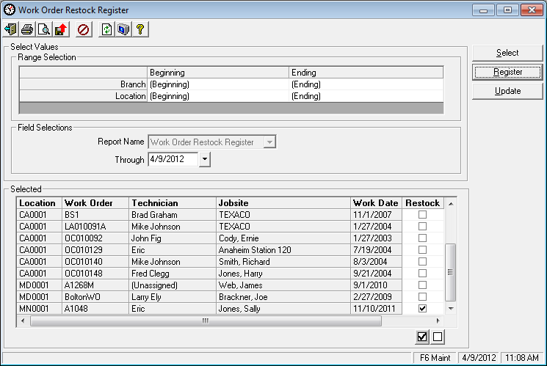

Figure 16: Work Order Restock Register - Runtime Options

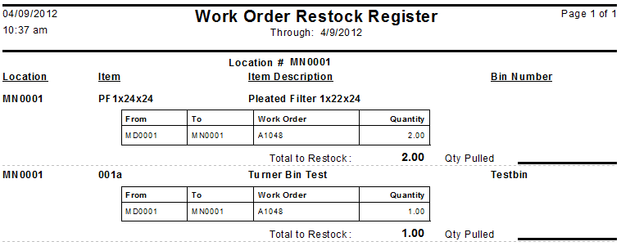

Figure 17: Work Order Restock Register Report

# Using the Inventory Movement Report to See Your Transactions

The Inventory Movement Report is used to review the summarized activity for items at each location for a specific fiscal period. It will provide your starting balance, the total ins and outs and a final ending balance. Use this to determine the net change for an item and location for a period.

The Inventory Movement Report shows beginning amounts, summarized activity, and ending amounts for a selected history period and fiscal year.

The system calculates the beginning quantity from history. The transactions listed are for the selected period and year. The ending quantity is calculated by adding and subtracting the transactions from the beginning quantity.

Traverse / Inventory / Reports / Inventory Movement Report

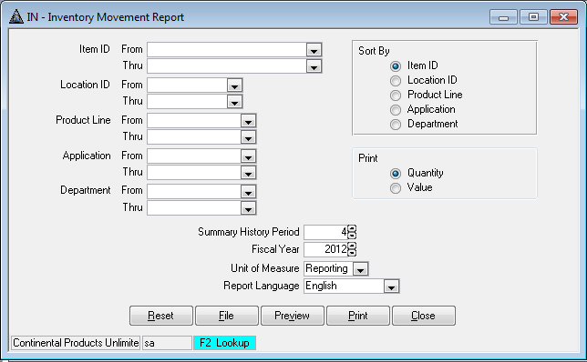

Figure 18: Traverse - Inventory Movement Report

