System Wide Changes

Works with Traverse 10.5 – New!

Ascente 3.5 only works with Traverse 10.5. To upgrade to this version of Ascente, Traverse must also be upgraded at the same time.

SQL Settings – New!

The following new options have been added to the System, Maintenance, Options and Interfaces program:

Command Timeout
Prior to this change you would get a timeout error if the SQL request took more that 30 seconds. Some custom reports may take longer than this to process. Now you can increase the Timeout limit to avoid this error.

Access Locking (Nolock)
This was previously set in the Ascente.ini file. This should normally be checked.

Update Locking (Rowlock)
This was previously set in the Ascente.ini file. This should normally be checked.

NOTE: All users will need to log out of Ascente before these changes will take effect.

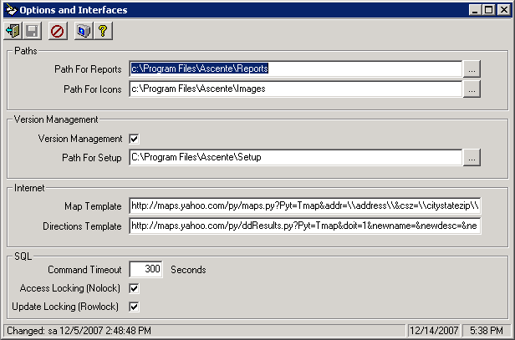

Notes Pro Module - New!

A new Notes Pro module has been added to Ascente. This is an add-on module available for purchase. Please check with your sales representative for pricing information.

The Notes Pro application allows users to insert folders, files and text into the Notes feature in Ascente. The user interface is simple and allows for many different types of files, such as pictures, spreadsheets, and word documents. See the Notes Images section below for more details.

If the user needs to scan documents, they will need to have a scanner installed on their workstation that puts the scanned documents in a directory on a server machine that allows access to the whole office.

Additionally, a Priority has been added to each Note to which will change the Notes icon that displays on the toolbar for Entry/Maintenance task as well as allow the user to flag a Note to automatically display. See the Notes Priority section below for more details.

Ascente Features & Enhancements

All maintenance tasks allow the users to enter and view notes for each table. The user will now be able to easily insert folders, files and text into each note. To show this feature, let’s use Job Maintenance as an example. The toolbar includes a Notes icon as shown below.

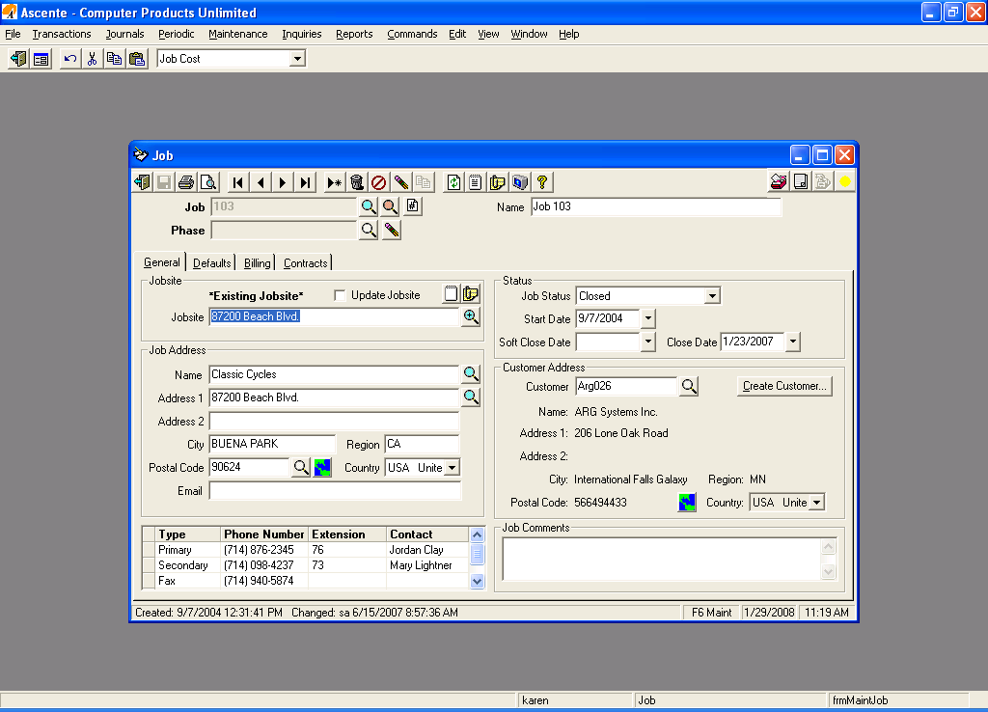
Clicking on this Notes toolbar button will launch Notes Maintenance as follows:

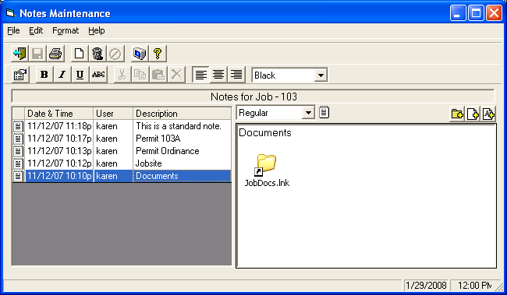

The circled buttons on the right are new buttons that have been added for the new Notes Pro functionality.
  - Inserts a link into the Note that contains a folder where the associated documents or images exist. Double clicking on this from Notes Maintenance will bring up and display all of the files that exist in that folder.

Clicking on the JobDocs.lnk will bring up the following folder:

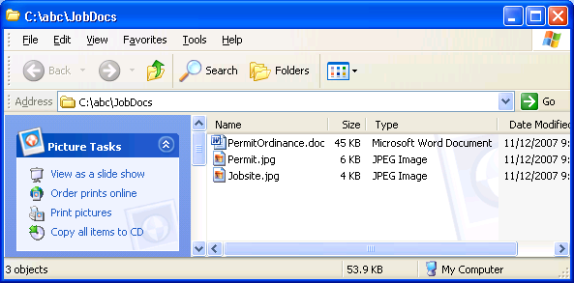
  - Inserts a link into the Note containing the full path name of the document or image itself. Double clicking on this from Notes Maintenance will bring up the appropriate associated program. For example, .doc files will bring up MS Word and .jpg files will bring up the default image viewer.
Below is an example of an image being added to a Note:

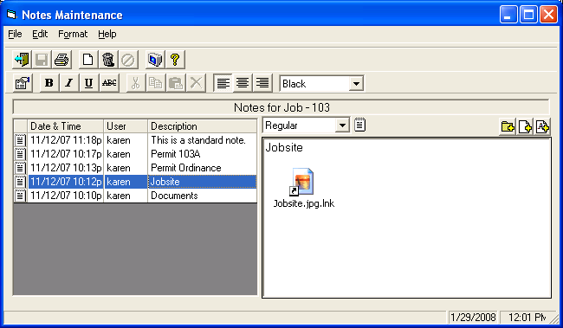

Clicking on the Jobsite.jpg.lnk is a link to an actual image so will bring up the image in the default image viewer:

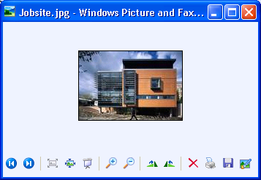
Below is an example of a MS Word document being added to a Note:

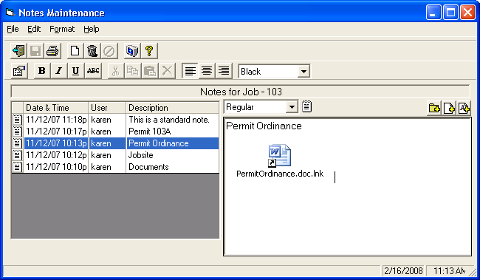

Clicking on the PermitOrdinance.doc.lnk is a link to an actual MS Word document so will bring up the file in that application:
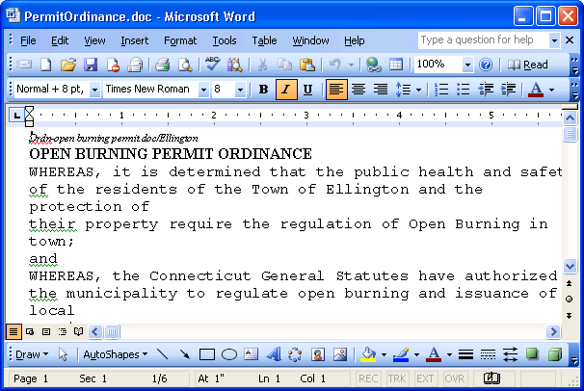
  - Inserts actual text from the file specified. This can be used if the user has some kind of a text based template that they want inserted into a particular document type. For example, if the user wants to enter custom type fields for a particular document type, they can setup a template containing the field captions they want entered and inserting this file will take the text from that template and load it into the current Note.

Below is an example of a text being added to a Note from a file or template.

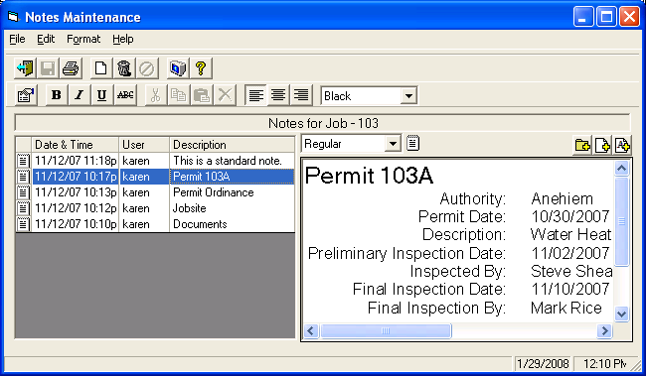
Once the user selects the Add Text button, the user can then select from templates that they’ve defined for this type of document. In this example, we have setup a Template.doc.

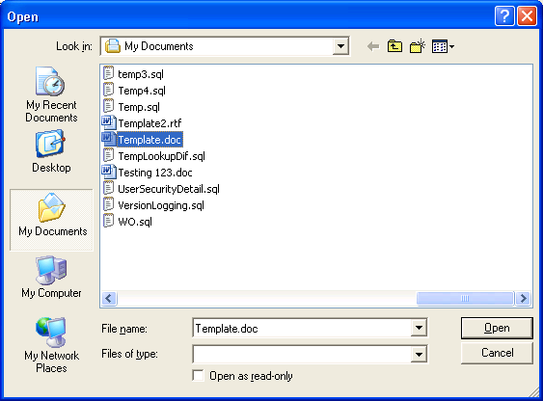

When the user selects that document, the following is added into the Note as text as allows the user to enter additional information if necessary. In the following example, the captions were added from the template (outlined in red) and the remaining was entered by the user. This will allow the user a method to enter custom fields for each document that can be kept consistent as long as they use the same templates.

Ascente Features & EnhancementsPriority

The user can now prioritize Notes by setting the priority of each note which will change the Notes icon that displays in the toolbar of Entry/Maintenance tasks. There is an Alert User priority that will automatically display Notes Maintenanace to the user if any note is flagged that way. The priority values can be set as follows:
- Regular
  - This is a regular note.
  - If this appears in the toolbar of the Entry/Maintenance task, this means there is at least one Note with a Regular priority and no other priorities exist.

- Important
  - This is an important note.
  - If this appears in the toolbar of the Entry/Maintenance task, this means there is at least one Note with an Important priority but no Alert User Notes.
- Alert User
  - This is a note that requires immediate attention and/or viewing so the user must be alerted.
  - If this appears in the toolbar of the Entry/Maintenance task, this means there is at least one Note with an Alert User priority. This type of Note will automatically launch Notes Maintenance to force the user to see this note.

See the example below of a record that has a Note with an Alert User priority. The following icon will display in the toolbar when the record is brought up.

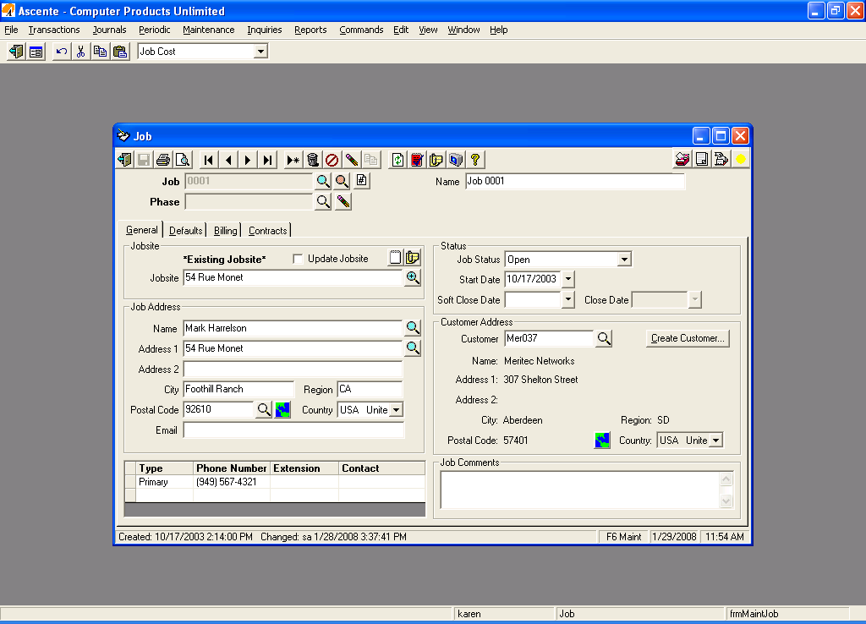

If an Alert User Note exists, Notes Maintenance will automatically display as follows:

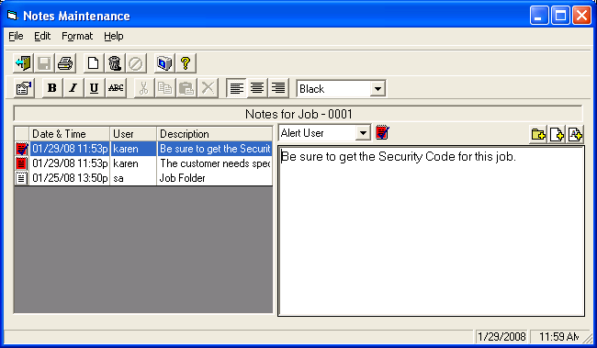

The Priority can be changed by the user and the icon displayed to the right (and in the selection grid to the left) will be updated appropriately. The selection grid on the left has been changed to include the Priority icon as well as the Description which is the first line of text of the note. It also has been changed from displaying in inverse Date & Time order to now display in Priority (Alert User, Important, Regular) and then inverse Date & Time order. This way, the notes are grouped by Priority and appear in most important to least important order with the most current dates first.
Service Dispatch Changes

Call Taking

A new Custom Fields icon has been added to the right of the Jobsite Notes button, if Custom Fields have been created for Jobsites.

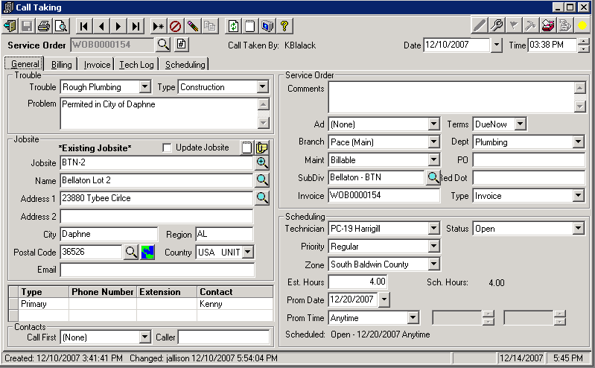

Service Order Print

The last 5 service calls from history for the Jobsite can now be printed on the Service Order form. The standard form distributed with the software will automatically print these, but if the user currently has a customize form it will need to be modified to print the new fields.

Prebill and Invoice

The Prebill Reports and the Invoice form can now be modified to print the Component Id, Manufacturer, Model and Serial Number for the Component assigned to the header of the Work Order or to the line items.

Workmans Compenstation Report

The Workmans Compensation Report now includes the YTD Earnings in the record set. This allows for the report to be modified to support limits on some comp codes (like executives). The limit will have to be hard coded in the report. Note that the YTD Earnings will be at the time the report is run. This means that you will NOT be able to rerun the report for old periods if limits are in place.
Job Cost Changes

Job Maintenance

A new Custom Fields icon has been added to the right of the Jobsite Notes button, if Custom Fields have been created for Jobsites.

